3D amperometry in the liquid chromatographic determination of trace pharmaceutical and herbicide emerging compounds
Luca Rivoira*¹, Michele Castiglioni¹, Massimo Del Bubba², Maria Concetta Bruzzoniti¹
¹Department of Chemistry, University of Torino, via P. Giuria 7, 10125 Torino, Italy
²Department of Chemistry, University of Florence, via Lastruccia 3, 50019 Sesto Fiorentino, Italy
*Corresponding Author:
Luca Rivoira, PhD
Department of Chemistry, University of Torino, via P. Giuria 7, 10125 Torino, Italy
Email: luca.rivoira@unito.it
Tel: 0039-0116705245
Fax: 0039-0116705242
ORCiD: 0000-0002-5849-1119

3D amperometry in the liquid chromatographic determination of trace pharmaceutical and herbicide emerging compounds

Nowadays, the quality of surface waters is worsened by the presence of several pollutants such as herbicides, drugs and their metabolites, with different physicochemical properties. Chromatographic methods for environmental monitoring can frequently show coelutions that require expensive selective detection like mass spectrometry.
In this work, we innovatively applied the 3D Amperometry detection, coupled to liquid chromatography, for the determination of a mixture of chromatographically unresolved compounds (two herbicides, monuron and bentazon, one drug, propranolol, and the main metabolite of an antiepileptic drug, 5-(4'-hydroxyphenyl)-5-phenylhydantoin). Exploiting the post-chromatographic current integration, a scanning waveform was successfully applied to explore a wide range of potentials (0.0-1.3 V) to find the peculiar oxidative potential value for each compound. This approach allowed us to obtain 3D chromatograms (elution time vs potential vs current) in which coeluted species could be clearly distinguished.
Quantitation was easily obtained by extraction of 2D chromatograms (elution time vs integrated current), from the 3D ones, at the optimized waveform time ranges (800-1000 msec and 1500-1700 msec, corresponding to 0.6-0.8 V and 1.0-1.2 respectively). Validation of the proposed 3D amperometry method was performed in terms of linearity, limits of detection and quantitation and repeatability. Matrix effect was studied by statistical treatment on a wastewater effluent. By coupling an on-line solid phase extraction step prior to separation and detection by 3D Amperometry, detection limits were significantly reduced (57 ng/L for bentazon, with recovery yields of 82.9±10.9%). Worth to mention that this value fully satisfies the requirements of the 98/83/CE directive for the determination of bentazon in groundwater.

Keywords: HPLC-3DAmp; on-line SPE; drugs; herbicides; pulsed amperometric detection

Introduction
In recent years, a vast number of organic contaminants, mainly derived from pharmaceutical consumption, industrial and agricultural activities, is worsening the quality of surface and ground water all over the world.
Within pharmaceutical compounds, many monitoring campaigns on the quality of surface waters highlight the presence of highly prescribed drugs such as beta-adrenoceptor blocking drugs (e.g. atenolol and propranolol) and antiepileptic drugs [1][1, 2]. Removal of the above-mentioned compounds by biological secondary treatments can vary according to the physicochemical characteristics of the target analytes, to the characteristics of wastewater treatment plants (WWTPs) and to the characteristics of the influent waters.
Among the beta-adrenoceptor blocking drugs, although propranolol is a drug less prescribed than atenolol, its removal efficiency by WWTPs is lower than that of atenolol, as highlighted by many studies [1, 2]. Differently from atenolol, the presence of propranolol was also observed in the sludges derived from biological secondary treatments [3].
Within the chemical compounds used for agricultural activities, bentazon, a post-emergence herbicide belonging to the thiadiazine class, is among the herbicides most used for the control of weeds. Bentazon exhibits acute and chronic toxicity [4] and was widely detected in both surface and groundwaters in various European countries [5], including Italy at concentrations as high as 16 µg/L in groundwaters and 1.8 µg/L in surface waters [6]. Since 2007, the use of bentazon in Italy is subjected to phytosanitary restrictions in vulnerable areas such as those of Piedmont Region [7], whereas since 2008, bentazon is included in Annex III (Substances subject to review for possible identification as priority substances or priority hazardous substances) of the EU Directive 2008/105/EC [8]. Another frequently used herbicide is monuron, a phenylurea derivative, widely applied because of its inhibition of photosynthesis [9]. This is a persistent contaminant (10 months) which can pollute water and soil resources, and which is poorly removed by common wastewater treatment technologies [10].
The analytical determination of the above-mentioned compounds is mainly performed by LC–MS and LC–MS/MS methods which today represent the most sensitive and selective techniques for the determination of a large number of pollutants of medium-high polarity in waters. If coupled with SPE protocols, these techniques can achieve ppt or sub ppt levels [11, 12]. Despite their unquestionable advantages, the quite relevant costs of the MS and above all of the MS/MS systems make the diffusion of these approaches difficult in many laboratories.
Electroanalytical techniques coupled with chromatographic separations offer interesting detection specificity and sensitivity at low cost. The type of the working electrode used depends on the chemical characteristics of the analytes. As an example, sulfur-containing pesticides were determined below hundreds of µg/L levels at a gold electrode by pulsed amperometric detection [13]. Our research group has recently shown the possibility of determining herbicides and pharmaceuticals by HPLC-pulsed amperometric detection using a glassy carbon electrode at sub-µg/L levels in water samples after off-line solid phase extraction [14] or at µg/kg levels in soils after extraction and clean-up by the QuEChERS [15] approach.
One among the newest amperometric techniques is the 3D Amperometry (3DAmp) in which a continuous acquisition of current is enabled throughout the entire waveform period, rather than only during a predefined period. This complete data-set enables post-chromatographic current integration of the amperometric data (pulsed amperometry). If compounds have different oxidative potentials (as in the case of many electroactive environmental pollutants) this technique allows, in only one analysis, to distinguish all the injected molecules, even if they elute at the same retention time [16].
To the best of our knowledge, 3DAmperometry has been only applied to the separation and determination of unknown mixtures of carbohydrates and amino acids [16] but so far, no application of this technique to pesticide and drug analysis has been demonstrated.
In this work, a 3DAmp detection has been applied for the determination of chromatographically unresolved compounds. Bentazon, propranolol, monuron and 5-(4'-hydroxyphenyl)-5-phenylhydantoin (HPPH), the main metabolite of the anticonvulsant agent phenytoin (5,5-diphenylhydantoin) were chosen as target emerging contaminants.
Remarkable decrease in total analysis time, higher analytical throughput together with significant increase of the pre-concentration factor, would be expected by an on-line solid-phase pre-concentration and purification technique, automatically coupled with chromatographic system, as shown for the determination of various classes of organic micropollutants in environmental waters [17, 18]. For this reason, on-line solid phase extraction (SPE) sample preparation was also coupled with 3DAmp, pulsed amperometry, using bentazon as model compound.

Materials and methods

Reagents
All reagents used were of analytical grade. Standard solutions of target compounds (bentazon, HPPH, propranolol and monuron) were prepared at a concentration of 2 mg/L each, by solids obtained from Sigma Aldrich (Chemie, Steinheim, DE) and stocked at 3°C. Sodium formate, hydrochloric acid, and acetonitrile used for eluent preparation were from Sigma Aldrich, as well. A Milli-Q Plus ultra-pure water system from Millipore (Milford, MA, USA) was used for the preparation of standard solutions and eluents..

Instrumentation
For the chromatographic separation, a Dionex ICS-3000 chromatograph (Thermo Scientiﬁc, Sunnyvale, CA, USA), equipped with an AS40 autosampler and a reversed-phase C-18 column (LiChroCart PuroSphere RP-18, 125 mm x 3.0 mm, 5 µm, Merck) was used. The mobile phase (0.5 mL/min flow rate) was prepared by mixing an aqueous portion (50 mM sodium formate buffer, pH 3) with acetonitrile.. All the analyses were performed in isocratic mode. For direct injection, a 10 µL-injection loop was used.
On-line SPE was performed using a Model 9012 Varian pump coupled with a RP C18 micro-cartridge (1cm x 3.2mm, 5 µm, CPS Analitica, Italy). Cartridge was previously conditioned by flushing 5 mL CH₃CN followed by 5 mL ultrapure water. Cartridge was subsequently loaded with 90 mL of sample at 2.0 mL/min. After the elution of target compounds toward the analytical column, by flushing of eluent through the on-line SPE cartridge, CH₃CN (5 min at 2.0 ml/min) was flushed, in order to clean the cartridge and to condition it for the subsequent loading step.
Two detectors coupled in series were used, namely an AD25 Absorbance Detector (λ 252 nm) and a AD40 Electrochemical Detector (both by Thermo Scientiﬁc, Dionex), with a Ag/AgCl reference electrode and a glassy carbon (GC) working electrode. The set-up of parameters of the electrochemical detector will be discussed in a subsequent Section. Chromatographic and amperometric data (2D and 3D) were collected and elaborated by the software Chromeleon 6.80 (Thermo Scientiﬁc, Dionex). Chromatographic separations were recorded in 3D Amp mode, and 2D chromatogram were extracted by integrating the current in a specific waveform time range.

Wastewater sample
A wastewater (WW) sample was used to evaluate the matrix effect. WW was sampled at the outlet of a membrane biological reactor (MBR) which includes nitrification, denitrification and ultrafiltration stages. The sample was characterized for chemical oxygen demand (COD) and 5-day biochemical oxygen demand (BOD5), total suspended solids (TSS) and N content. Results were as follow: TSS = 8 mg/L, COD = 1744 mg/L and BOD₅ = 110 mg/L.

Results and Discussion

HPLC – 3D Amperometric (3DAmp) detection
The target compounds have functional groups easily oxidable at a glassy carbon electrode, i.e. hydroxyl group for HPPH and propranolol, thiadiazine ring for bentazon and amide group for monuron [19]. Hence, an amperometric detection was studied. The starting detection waveform (Fig. 1A) used was derived according to previous results of our research group on bentazon and HPPH [14]. Accordingly, the oxidative detection potential was set at 1.20 V. A cleaning step is performed by a rapid change from reductive (E=-2.0 V) to oxidative conditions (E=1.8 V), to avoid electrode fouling. As regards non-faradaic effects, the CV profiles [14] highlighted the presence of some capacitive current which nevertheless did not hinder the quantitation procedure [14].
Figure 1
The following chromatographic conditions were used: 60% of a solution containing 50 mM HCOOH/HCOONa, pH 3.0 and 40% CH₃CN, which allowed a total analysis time of less than 5 min. These conditions provide the elution of all the analytes (t_{propranol}=2.1 min, t_{HPPH}=2.3 min, t_{bentazon}=3.3 min, t_{monuron}=3.6 min), with good peak shape (Asymmetry factors, propranolol: 1.05; HPPH: 1.03, bentazon: 1.06, monuron: 1.04) but with the coelution of the pairs propranolol/HPPH (Resolution= 0.42) and bentazon/monuron (Resolution= 0.64) as shown in Figure 2.

Figure 2The discrimination of coeluted compounds is possible through their different electrochemical behaviour. In fact, since the coeluted compounds have different structures, they oxidize differently at given applied voltages: this feature can be exploited, integrating current through different time periods within the waveform ramp (3D amperometry).
Under this rationale,. the previously applied waveform was set as a scanning waveform ramp, covering a wide range of oxidative potentials (from 0.0 to 1.3 V, see Figure 2B). In such a way, all the potential ranges that could be useful to oxidize target analytes are explored. A pre-adsorption potential of 0.2 V for 10 msec was added to promote adsorption of analytes on the electrode surface before the oxidation step [20]. These conditions were optimized by studying the response value (peak area) for bentazon, as a function of the applied pre-adsorption potential (0.0, -0,2, -0,4 V) and time (1, 2, 5, 10 msec).

As a result, the amperometric detection is enhanced as a 3-dimensional amperometric detection (3D-Amp) , where results are displayed in a three-dimensional space (current, potential, and retention time) and peaks appear as contour plots well separated each other. Figure 3 shows a typical 3D-chromatogram, obtained by injection of a mixture of standard solution of target analytes at 2 mg/L, each.
Figure 2

Figure 3
In the 3DAmp chromatogram, elution time is represented on the x-axis, while the waveform time is represented on the y-axis. Colours (the third dimension) represent the intensity of the signal obtained after integration of the current in a precise range of the times of the waveform (in the figure, it is the space included within the two thick black lines). Additionally, on the left of the graph, the potential waveform is represented in blue line while in black line, the I-t plot is shown. The I-t plot represents the total current, registered at a defined retention time, deriving from the oxidation of electroactive groups. Maxima of this curve (red dots) will be in correspondence of higher signal (currents) obtained, thus helping to choose the useful integration time waveform ranges, corresponding to specific potential ranges.
From the 3D chromatogram, it is possible to see that HPPH and propranolol, which are expected to elute at the same retention time, could be clearly distinguished, as well as bentazon and monuron, since, as desired, the two pairs of species are oxidized at different potentials and therefore integration must be performed at different waveform times. So, propranolol and monuron, must be integrated in a range from 800 to 1000 msec (in this range, potentials from 0.6 to 0.8 V are scanned) whereas HPPH and bentazon must be integrated in the final part of the ramp, i.e. from 1500 to 1700 msec (corresponding to potentials from 1.0 to 1.2V). It is worth to note that, these potential ranges are in good agreement with the ones already published in literature using traditional pulsed (2D) amperometry [21, 22], which however is not able to resolve the coelution of analytes.

Validation of the HPLC – 3DAmp method in treated wastewater
In the previous paragraph, 3DAmp has been demonstrated suitable to resolve chromatographic coelutions of the target analytes. In order to apply this method for the determination of bentazon, HPPH, monuron and propranolol in real samples, validation should be prior performed.
The real sample studied here was treated wastewater. This choice was driven by the need to limit the contamination of recipient water bodies, as well as by the urgent and current needs of using treated wastewaters for irrigating purposes in countries where freshwater resources are becoming insufficient to sustain agricultural irrigation, mainly due to climate-related conditions.
Linearity of the proposed 3DAmp method was evaluated by injecting six different solutions containing the four analytes at a concentration range from 1 mg/L to 10 mg/L (for bentazon and monuron, useful calibration range was from 2 to 10 mg/L, five levels). Standards were prepared both in ultrapure water and in treated wastewater (matrix-matched calibration), in order to evaluate any possible interfering effect in the 3DAmp detection. 2D chromatograms (elution time vs integrated current) were extracted from the 3D one, as described, at the previously optimized ranges (800-1000 msec and 1500-1700 msec). Injections were performed in triplicates for each calibration level. Limits of detection (LODs) and limits of quantitation (LOQs) were evaluated in wastewater sample as follow: LOD = 3 × SD_{xy}/b and LOQ = 10 × SD_{xy}/b (where SD_{xy} is the standard deviation of the response and b is the slope of the matrix matched calibration curve). Results are summarized in Table 1.
Table 1
Linearity of the 3DAmp method is observed also in wastewater. The presence of a matrix effect was tested by comparing the slopes of curve obtained in ultrapure water and in wastewater by means of a Student’s t-test [23] (probability of 95%). There is no significant difference between the slopes of both calibration curves, meaning that no matrix effect is present, when the Student t value is below the tabulated t with r_{UW} + r_{WW} −4 degrees of freedom (18+18-4=32 for HPPH and propranolol, and 15+15-4=26 for bentazon and monuron), where r_{UW} and r_{WW} are the numbers of replicates for each calibration level in the curve in ultrapure water and in wastewater, respectively. t-values, calculated comparing equation curves, are summarized in Table 1 for each compound. No matrix effect was present as highlighted by the comparison of calculated values with the tabulated t-value (t=2.037 for HPPH and propranolol and t=2.134 for bentazon and monuron, respectively). It was therefore concluded that, despite the MBR effluent is characterized by a discrete amount of oxidable compounds (COD=1744 mg/L), the impact of the matrix affecting the 3DAmp detection is negligible.
Finally, inter-day and intra-day repeatability of the method (expressed as relative standard deviation, RSD %) was verified for peak areas, by repeatedly running a mixture of analytes at 1.5 mg/L for three days (5 replicates per day). For both measurements, RSDs% were lower than 12%.

Set-up of on-line SPE – HPLC – 3DAmp for bentazon
The 3DAmp approach can be applied for the identification of classes of compounds in which chromatographic coelutions occur, exploiting their different oxidative potential. In addition, through the extraction of corresponding 2D chromatograms, quantification of target compounds is possible. Nevertheless, it should be mentioned that LODs obtained for bentazon, HPPH, monuron and propranolol are about one order of magnitude higher if compared to the precautionary limit for pesticides in waters (0.1 µg/L). A pre-concentration procedure, based on an on-line SPE system, was therefore set up to reduce LODs values. An on-line system was selected to reduce sample manipulation, to increase the accuracy, due to the automatization of the procedure and to the increase the analytical throughput [24].
The on-line SPE-3DAmp configuration was set up for bentazon, chosen as model compound. This choice is justified by the emerging environmental concern of bentazon, the only compound officially regulated in groundwaters by the Directive 98/83/CE EU among the selected analytes.
Based on its chemical structure, a RP18 micro-cartridge was used to adsorb and to preconcentrate bentazon before its transfer to the analytical column.
At first, the capacity of the cartridge was evaluated by calculating the breakthrough curve using UV detection. Briefly, a solution at 100 µg/L of bentazon was flown at 0.2 mL/min inside the SPE cartridge, which was directly connected to a UV detector set at 225 nm. Once the cartridge is saturated and, therefore, bentazon is no longer retained by the sorbent, an increase of the recorded signal is observed. The curve shows an inflection point (t_{f} = 1.62 min), and finally reaches a plateau. Considering the area described by the curve and the initial concentration of the solution, the maximum amount of bentazon that can be loaded was 50 ng. This value satisfies the regulated limits for bentazon in groundwaters (100 ng/L): in fact, considering a loaded volume of 30 mL sample, a total amount of 3 ng could be retained on the stationary phase and volumes up to 16-times higher (480 mL) could be therefore theoretically loaded without achieving saturation of the cartridge. Recovery of bentazon was evaluated comparing the peak areas obtained by direct injection of sample (0.9 mg/L, loop 10 µL) with those obtained by loading the same nominal amount of analyte (100 ng/L in 90 mL) in the pre-concentration cartridge (pre-concentration factor 9000). A blank was processed in parallel. The recovery obtained for the on-line SPE was 82.9±10.9% (n=3).
Considering the previously calculated recovery, the new LODs of the methods were verified.
New calibration curves were obtained, by loading 100, 150, 200, and 1000 ng/L bentazon (90 mL at 2 mL/min). Linearity was confirmed over one order of magnitude. As expected by the pre-concentration factor and by the recovery yield, LODs for bentazon, calculated as described in paragraph 3.3, was 57 ng/L, which was verified by processing a sample at this bentazon concentration. This limit satisfies the requirements of the EU directive for the determination of bentazon in groundwater.
If compared with LODs obtained for bentazon by LC-MS/MS or GC-MS analysis,derived from literature data, the presented method has sensitivity performances just one and a half order of magnitude lower (2.0 ng/L by on-line SPE-LC-MS/MS, and 1.5 ng/L by GC-MS) [25, 26]. Additionally, the good performances of the on-line-SPE-3DAmp method are achieved by an instrumentation characterized by lower acquisition and management expenses than a MS/MS system. Moreover, the overall procedure is not affected by long sample preparation efforts, as it happens for the GC analysis of bentazon that should be preceded by a derivatization step.

Conclusions
In the present work, 3D amperometry was applied for the first time in the HPLC separation of selected common drugs (propranolol and HPPH derivative) and pesticides (bentazon and monuron), which in recent years affect the quality of natural water resources. The evaluation of a scanning waveform allows to explore a wide range of potentials, covering the oxidative potentials of all the target analytes in a unique analysis, recording each current in a 3D chromatogram. Moreover, the extraction of 2D chromatograms, obtained after integrating the current in a specific range of the scanning waveform, allows to perform quantitative analysis of target compounds. The sensitivity of the HPLC-3DAmp method can be enhanced by coupling an on-line SPE procedure. The whole approach represents a powerful high-throughput technique capable of solving chromatographic coelutions, without the need of stressing chromatographic separation optimization or the use of mass spectrometric equipment. After optimization, the detection limit achieved for bentazon by on-line SPE 3D-Amp technique was 57 ng/L, compatible with the EU directive for the determination of bentazon in groundwater, thus suggesting a possible application of the presented method for the determination of bentazon in real water samples.

Acknowledgements
The authors would like to thank Dr. Valentina Febbraio for her kind assistance in laboratory experiments. Financial support from ERANET-MED (project 13-069) and from Ministero dell’Istruzione, dell’Università e Ricerca, Italy (MIUR) is gratefully acknowledged.

References
[1] B. Kasprzyk-Hordern, R. M. Dinsdale and A. J. Guwy, Water Res. 43 (2), 363-380 (2009). doi: 10.1016/j.watres.2008.10.047.
[2] B. Petrie, R. Barden and B. Kasprzyk-Hordern, Water Res. 72, 3-27 (2015). doi: 10.1016/j.watres.2014.08.053.
[3] M. Gardner, V. Jones, S. Comber, M. D. Scrimshaw, T. Coello ‐ Garcia, E. Cartmell, J. Lester and B. Ellor, Sci. Total Environ. 456, 359-369 (2013). doi: 10.1016/j.scitotenv.2013.03.088.
[4] World Health Organization, 2016.
[5] R. Loos, G. Locoro, S. Comero, S. Contini, D. Schwesig, F. Werres, P. Balsaa, O. Gans, S. Weiss, L. Blaha, M. Bolchi and B. M. Gawlik, Water Res. 44 (14), 4115-4126 (2010). doi: 10.1016/j.watres.2010.05.032.
[6] R. Meffe and I. de Bustamante, Sci. Total Environ. 481, 280-295 (2014). doi: 10.1016/j.scitotenv.2014.02.053.
[7] Ministero della Salute della Repubblica Italiana, in G.U. 28 maggio 2007, n. 122 (2007).
[8] European Community, (2008).
[9] L. S. Jordan, T. Murashige, J. D. Mann and B. E. Day, Weeds, 134-136 (1966). doi: 10.2307/4040945
[10] S.-W. Nam, D.-J. Choi, S.-K. Kim, N. Her and K.-D. Zoh, J. Hazard. Mater. 270, 144-152 (2014). doi: 10.1016/j.jhazmat.2014.01.037
[11] B. Kasprzyk-Hordern, R. M. Dinsdale and A. J. Guwy, J. Chromatogr. A 1161 (1), 132-145 (2007). doi: 10.1016/j.chroma.2007.05.074.
[12] S. K. Behera, H. W. Kim, J.-E. Oh and H.-S. Park, Sci. Total Environ. 409 (20), 4351-4360 (2011). doi: 10.1016/j.scitotenv.2011.07.015.
[13] A. Ngoviwatchai and D. C. Johnson, Anal. Chim. Acta 215, 1-12 (1988). doi: doi.org/10.31274/rtd-180813-9317
[14] L. Rivoira, R. M. De Carlo, S. Cavalli and M. C. Bruzzoniti, Talanta 131, 205-212 (2015). doi: 10.1016/j.talanta.2014.07.070.
[15] R. M. De Carlo, L. Rivoira, L. Ciofi, C. Ancillotti, L. Checchini, M. Del Bubba and M. C. Bruzzoniti, Anal. Bioanal. Chem. 407 (4), 1217-1229 (2015). doi: 10.1007/s00216-014-8339-x.
[16] Thermo Fisher Scientific, Application Note 179 (2007).
[17] L. Ciofi, C. Ancillotti, U. Chiuminatto, D. Fibbi, B. Pasquini, M. C. Bruzzoniti, L. Rivoira and M. Del Bubba, Anal. Bioanal. Chem. 408 (12), 3331-3347 (2016). doi: 10.1007/s00216-016-9403-5.
[18] T. Vega-Morales, Z. Sosa-Ferrera and J. J. Santana-Rodríguez, J. Chromatogr. A 1230, 66-76 (2012). doi: 10.1016/j.chroma.2012.01.077.
[19] A. Sánchez, R. C. Guillén-Villar, R. Sánchez, R. Vargas, J. Garza, M. H. Matus, M. Salas-Reyes and Z. Domínguez, Electrochim. Acta 133 (Supplement C), 546-554 (2014). doi: 10.1016/j.electacta.2014.04.082.
[20] J. Cheng, P. Jandik, Y. Liu and C. Pohl, presented at the Meeting Abstracts, 2013 (unpublished).
[21] Z. Kun, H. Yi, Z. Chengyun, Y. Yue, Z. Shuliang and Z. Yuyang, Electrochim. Acta 80 (Supplement C), 405-412 (2012). doi: 10.1016/j.electacta.2012.07.053.
[22] E. Manuela Garrido, J. L. Costa Lima, C. M. Delerue-Matos and A. Maria Oliveira Brett, Talanta 46 (5), 1131-1135 (1998). doi: 10.1016/S0039-9140(97)00380-9.
[23] D. Massart, B. Vandeginste, L. Buydens, S. De Jong, P. Lewi, J. Smeyers-Verbeke and C. K. Mann, Appl. Spectrosc. 52, 302A (1998). doi: 10.1016/s0922-3487(97)x8000-1
[24] S. Rodriguez-Mozaz, M. J. Lopez de Alda and D. Barceló, J. Chromatogr. A 1152 (1), 97-115 (2007). doi: 10.1016/j.chroma.2007.01.046.
[25] R. J. C. A. Steen, A. C. Hogenboom, P. E. G. Leonards, R. A. L. Peerboom, W. P. Cofino and A. T. Udo, J. Chromatogr. A 857 (1-2), 157-166 (1999). doi: 10.1016/s0021-9673(99)00772-4
[26] J.-L. Zhao, G.-G. Ying, L. Wang, J.-F. Yang, X.-B. Yang, L.-H. Yang and X. Li, Sci. Total Environ. 407 (2), 962-974 (2009). doi: 10.1016/j.scitotenv.2008.09.048

Figure captions

Figures 1A and 1B. Classical waveform used for amperometric detection (A) and scanning waveform set for 3D amperometry (B). in the 3D-Amp waveform the scanning ramp allows to explore the potential values that could be useful to oxidize target analytes.
Figure 2. Chromatogram obtained after the injection of 2 mg/L propranol, HPPH, bentazon and monuron mixed standard, using pulsed amperometric detection conditions of Figure 1A (integration of the current from 0.2 to 0.4 sec). The coelution of the pairs propranolol/HPPH and bentazon/monuron is clearly evidenced. Chromatographic conditions: C-18 column, 125 mm x 3.0 mm, 5 µm; mobile phase: sodium formate buffer (pH 3) 60%, CH₃CN 40%; ﬂow rate: 0.5 mL/min; 10 µL-loop.
Figure 3. A 3DAmp chromatogram obtained after the injection of a mixture containing bentazon, HPPH, propranolol and monuron at 2 mg/L each. Blue line on the left is the scanning waveform, black line is the intensity-time (I-t plot) plot at a defined retention time. Thick black lines include the waveform times within it is possible to integrate (the range could be modified as necessary). As it is possible to see, peaks that in the I-t plot coelute (only two peaks can be seen) can be fully separated choosing a different range time in the scanning waveform to be integrated (in simple words moving the range between black lines at the top of the waveform). This means that a new dimension is added to the chromatogram, as seen in the right part of the Figure, where four different peaks can be clearly distinguished. Chromatographic conditions as in Fig.2 Detection:3D Amp scanning waveform (Fig. 1B).

Table captions
Table 1. Linearity, LOD and LOQ values for the optimized 3DAmp method. Peak areas were extracted from corresponding 2D chromatograms. LODs and LOQs were calculated from the matrix matched calibration curve. LOD after on-line SPE preconcentration for bentazon is also presented.
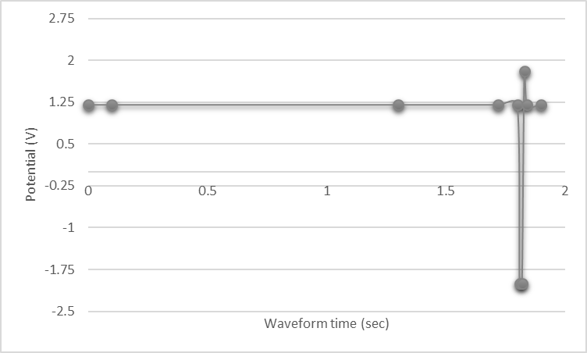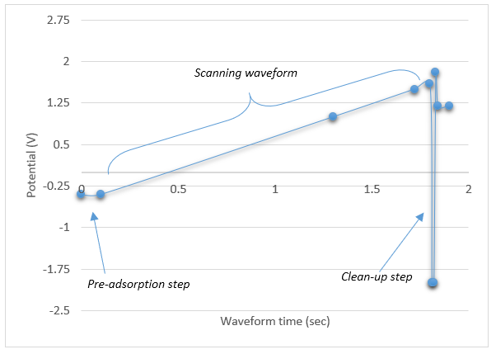
B
A
Figures 1A and 1B. Classical waveform used for amperometric detection (A) and scanning waveform set for 3D amperometry (B). in the 3D-Amp waveform the scanning ramp allows to explore the potential values that could be useful to oxidize target analytes.
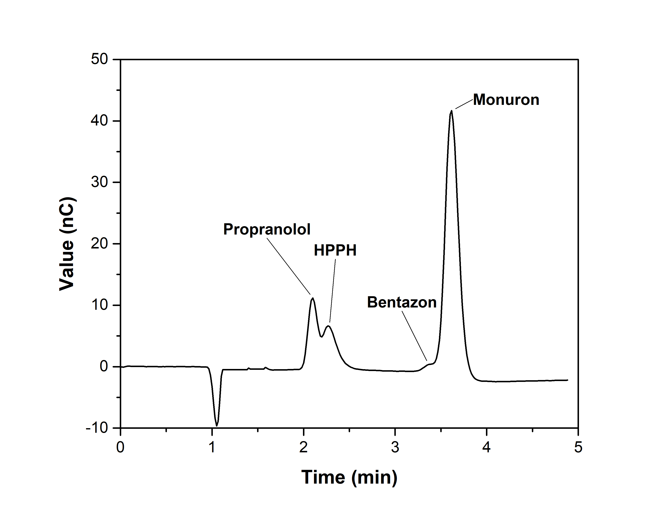
Figure 2. Chromatogram obtained after the injection of 2 mg/L propranol, HPPH, bentazon and monuron mixed standard, using pulsed amperometric detection conditions of Figure 1A (integration of the current from 0.2 to 0.4 sec). The coelution of the pairs propranolol/HPPH and bentazon/monuron is clearly evidenced. Chromatographic conditions: C-18 column, 125 mm x 3.0 mm, 5 µm; mobile phase: sodium formate buffer (pH 3) 60%, CH₃CN 40%; ﬂow rate: 0.5 mL/min; 10 µL-loop.

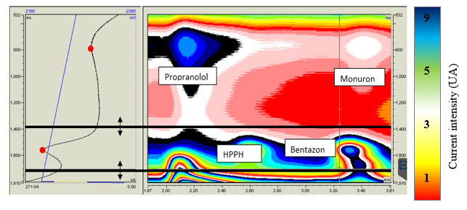
Figure 3. A 3DAmp chromatogram obtained after the injection of a mixture containing bentazon, HPPH, propranolol and monuron at 2 mg/L each. Blue line on the left is the scanning waveform, black line is the intensity-time (I-t plot) plot at a defined retention time. Thick black lines include the waveform times within it is possible to integrate (the range could be modified as necessary). As it is possible to see, peaks that in the I-t plot coelute (only two peaks can be seen) can be fully separated choosing a different range time in the scanning waveform to be integrated (in simple words moving the range between black lines at the top of the waveform). This means that a new dimension is added to the chromatogram, as seen in the right part of the Figure, where four different peaks can be clearly distinguished. Chromatographic conditions as in Fig.2 Detection:3D Amp scanning waveform (Fig. 1B).

Table 1. Linearity, LOD and LOQ values for the optimized 3DAmp method. Peak areas were extracted from corresponding 2D chromatograms. LODs and LOQs were calculated from the matrix matched calibration curve. LOD after on-line SPE preconcentration for bentazon is also presented.
Analyte | Linear equation |  |  | R² |  | LOD | LOQ | LOD SPE
 | in MilliQ water | in WW | t-value | in MilliQ | in WW | [mg/L] | [mg/L] | [mg/L]
Bentazon | y = 0.8133x - 0.2421 | y = 0.7983x - 0.2384 | 1.854 | 0.9996 | 0.9941 | 0.41 | 1.37 | 5.7·10⁻⁵
HPPH | y = 0.7634x - 0.145 | y = 0.7543x - 0.138 | 0.985 | 0.9954 | 0.9917 | 0.29 | 0.96
Propranolol | y = 0.2183x - 0.0518 | y = 0.2221x - 0.0521 | 0.542 | 0.9982 | 0.9913 | 0.12 | 0.40
Monuron | y = 0.1109x + 0.0458 | y = 0.1342x + 0.0583 | 1.624 | 0.9926 | 0.9885 | 0.37 | 1.24

