A simplified method for the sizing of full-scale Aerobic Granular Sludge Wastewater Treatment Systems
Alessandro Alberti^{1*}, Matteo Venturi², Francesco Avolio², Paolo Gelli², Claudio Lubello¹, Tommaso Lotti¹
¹Department of Civil and Environmental Engineering, University of Florence, Italy
²Hera SpA - Water Direction, Modena, Italy
*Corresponding author: alessandro.alberti@unifi.it.
Keywords: AGS; WWTP footprint; aeration energy
Highlights
- Lack of secondary clarifiers impacts AGS volume savings more than reactor size
- AGS’s high SRT results in smaller sludge production
- AGS leads to higher aeration energy consumption than CAS
Introduction
A feasibility study for the conversion of seven real Conventional Activated Sludge (CAS) municipal WasteWater Treatment Plants (WWTPs) managed by Hera SpA (Table 1) into Aerobic Granular Sludge (AGS) WWTPs was performed.
The study consisted in developing a simple (i.e. not involving advanced mathematical modeling) method to size AGS WWTPs with predefined pollutant removal efficiencies, based on data from real AGS systems. The parameters calculated included (i) biological reactor volume (V_{bio}), (ii) total plant volume (V_{tot}), (iii) total plant area (S_{tot}), (iv) excess sludge production (P_{x}), (v) electrical energy consumption for aeration (EE_{aer}); (vi) electrical power installed for aeration (P_{aer}).
The results were used to (a) compare the performances of AGS and CAS in the six fields mentioned above; (b) calculate first-guess values for the sizing of AGS plants based on their capacity.
Materials and methods
Typical values of wastewater flowrates (daily average, Q, and daily dynamics) and pollutant concentrations (influent and effluent) were obtained for each WWTP, based on real measurements supplied by the plants’ managers.
A Nereda® configuration (Pronk et al. 2015), was chosen for the AGS reactors, consisting in Sequencing Batch Reactors (SBRs) with cycles divided into four phases: (i) anaerobic simultaneous feeding and discharge (phase duration in minutes: t_{f}), (ii) aeration (t_{aer}), (iii) anoxia (t_{anox}), (iv) sedimentation (t_{s}). A maximum Volume Exchange Ratio (VER) of 0.6, a 7 m height and a biomass concentration of 10 gTSS/L were chosen.
V_{bio} was calculated with Equation 1. t_{f} and t_{s} were fixed respectively to 60 and 30 minutes, which were reasonably deemed sufficient for COD uptake and sedimentation (Pronk et al. 2015). A time-step based spreadsheet simulation of the concentration profiles of Total Kjeldahl Nitrogen, Total Nitrogen and Total Phosphorus was performed. Nitrification, denitrification and dephosphatation kinetics were based on rates reported by Pronk et al. (2015), adjusting for biomass concentration and influent COD/TKN ratios to account for microbial community adaptations. t_{aer} and t_{anox} were chosen as the minimum durations assuring the meeting of required effluent standards.
 | $$V_{bio}=\frac{Q (t_{f}+t_{aer}+t_{anox}+t_{s})}{1440VER}$$ | 1
V_{tot} was calculated adding V_{bio} and V_{eq}, the latter indicating the flowrate equalization volume. V_{eq} was calculated graphically (Metcalf and Eddy 2014), accounting for SBR phase durations and daily flowrate dynamics. S_{tot} was obtained by dividing V_{tot} by the tanks’ height.
P_{x}, EE_{aer} and P_{aer} were calculated according to Metcalf and Eddy (2014). For P_{x}, biomass decay rates were assumed to be reduced by 50% during t_{f}, t_{anox} and t_{s}. EE_{aer} and P_{aer} were calculated in two scenarios: (1) AGS aeration α-factor reduced by 33% compared to CAS and (2) AGS with the same α-factor as CAS, to account for differences between literature studies (Strubbe et al. 2023).
Results and Discussion
Table 2 summarizes whether AGS or CAS resulted in better performances for each of the analysed parameters for the seven WWTPs.
AGS usually performed better than CAS in terms of V_{bio}, but there were two exceptions. Furthermore, differences between the two technologies were moderate (as low as 6%). The absence of secondary clarifiers was instead the most important factor impacting V_{tot}, which always resulted smaller for AGS. The same happened for S_{tot} and P_{x}, due to the AGS reactors’ greater height and Sludge Retention Time (SRT).
CAS usually performed better for aeration-linked parameters in both α-factor scenarios, due to the high SRT of AGS WWTPs. In scenario (2), however, EE_{aer} differences between AGS and CAS were very small (7% on average). P_{aer}, conversely, was always higher in AGS for both scenarios, due to SBRs having discontinuous aeration. These results highlight that further studies are needed to address the literature gap concerning AGS α-factors. Other elements whose quantification could be crucial to establish which technology is more energetically efficient, such as recycle flows, were not included in this study.
Figure 1 shows the correlations between each plant’s capacity and the calculated parameters. The high R² values testify that the results of this study can be used to obtain first-guess values for sizing AGS plants treating municipal wastewater based only on the municipalities’ p.e.
Conclusions
This study developed a sizing method for AGS WWTPs which would simplify the design of full-scale applications, allowing to get novel insights about benefits and downsides of AGS. The method, while theoretically coherent, must be validated by pilot-scale or modelling studies, to assess uncertainties tied to the complexity of AGS processes.
References
Pronk, M., De Kreuk, M. K., De Bruin, B., Kamminga, P., Kleerebezem, R. V., Van Loosdrecht, M. C. M. (2015). Full scale performance of the aerobic granular sludge process for sewage treatment. Water research, 84, 207-217.
Metcalf & Eddy, A. E. C. O. M. (2014). Wastewater engineering treatment and resource recovery. McGraw-Hill Education.
Strubbe, L., van Dijk, E. J., Deenekamp, P. J., van Loosdrecht, M. C., & Volcke, E. I. (2023). Oxygen transfer efficiency in an aerobic granular sludge reactor: Dynamics and influencing factors of alpha. Chemical Engineering Journal, 452, 139548.

Figures and Tables
Table 1 Analysed WWTPs (real names anonymised).
WWTP | Capacity (p.e.)
Plant 1 | 606 137
Plant 2 | 246 830
Plant 3 | 168 957
Plant 4 | 100 746
Plant 5 | 25 996
Plant 6 | 16 638
Plant 7 | 10 012
Table 2 Comparison between AGS (favourable for parameters in green cells) and CAS (red cells). For EE_{aer} and P_{aer}, the upper and lower parts of the cells respectively refer to α-factor scenarios (1) and (2).
 | V_{bio} | V_{tot} | S_{tot} | P_{x} | EE_{aer} | P_{aer}
Plant 1
Plant 2
Plant 3 |  |  |  |  | 
Plant 4
Plant 5
Plant 6
Plant 7
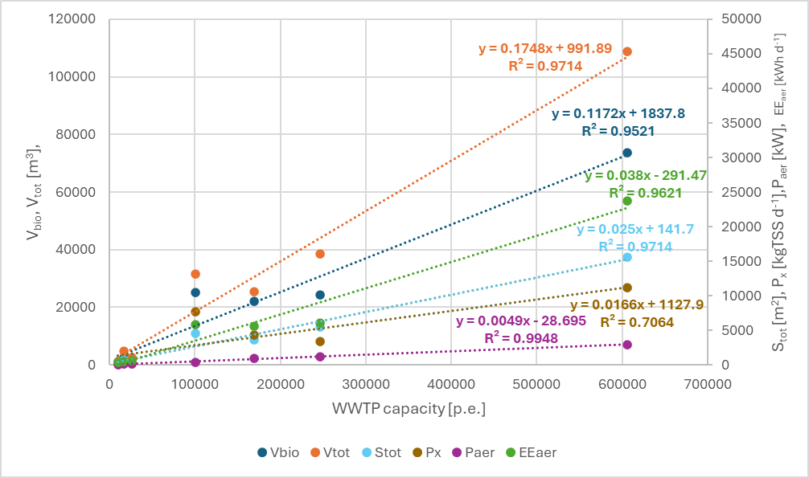
Figure 1 Results as a function of WWTP capacity.

