PROBING THE ROLE OF STRUCTURAL DISORDER IN SARS-COV-2 N BY NMR: INSIGHTS INTO POLYANION BINDING MECHANISMS
Tessa Bolognesiª, Marco Schiavinaª, Cristina Ciabiniª, Stefano Elli^{b}, Michela Parafioriti^{b}, Marco Guerrini^{b}, Isabella C. Felliª, Roberta Pierattelliª

ª Department of Chemistry, Magnetic Resonance Center, University of Florence, Via L. Sacconi 6, Sesto F.no IT
^{b} Istituto di Ricerche Chimiche e Biochimiche G. Ronzoni, Via G. Colombo 81, Milan IT
E-mail: tessa.bolognesi@unifi.it

Keywords:
solution NMR, small molecules, biomolecules.

Among the structural proteins of SARS-CoV-2, the nucleocapsid (N) protein stands out for its pronounced structural heterogeneity and multifunctionality throughout the viral life cycle, including RNA packaging, genome replication, and immune modulation. Comprising 419 amino acids, the N protein features two folded domains (NTD and CTD) interspersed with three extensive intrinsically disordered regions (IDR1, -2, -3). The coexistence of ordered and disordered regions raises an important question: how does this heterogeneous structural organization influence its interaction with highly charged ligands such as RNA or heparins?
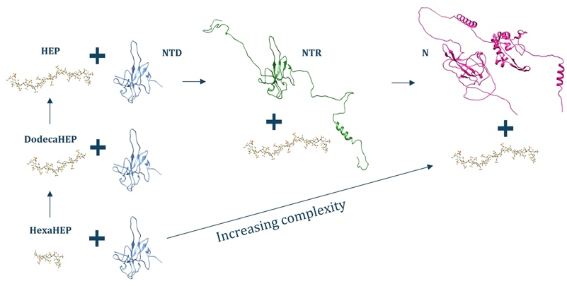
Extensive studies have investigated individual N protein constructs, particularly the N-terminal
domain (NTD, residues 44–180) and the N-terminal region (NTR, residues 1–248) [1, 2]. Building on this knowledge, we employed high-resolution NMR spectroscopy as the central analytical tool to characterize the interaction of the three N protein constructs— NTD, NTR, and N full length protein—with heparin-based ligands of increasing oligosaccharide length. Our NMR data reveal a clear correlation between ligand size and binding affinity: longer saccharide chains induce stronger and more widespread chemical shift perturbations, particularly within positively charged regions. Notably, the inclusion of intrinsically disordered segments in the NTR construct significantly enhances the interaction compared to NTD alone, underscoring the functional relevance of structural disorder. The full-length protein displayed distinct spectral behavior, potentially reflecting additional binding contributions from IDR3 and altered dynamics due to its complex and dimeric structure. These findings highlight the sensitivity and versatility of NMR spectroscopy in dissecting the dynamic and multivalent nature of protein–polyanion interactions, particularly in proteins with a complex domain architecture. Our results support a model in which disordered regions are not merely flexible linkers, but active modulators of ligand binding, capable of tuning interaction specificity and affinity. This work emphasizes the necessity of investigating full-length, multidomain proteins by NMR to fully capture the intricacies of their functional mechanisms.

References
[1] L. Pontoriero, M. Schiavina, S. M. Korn, A. Schlundt, R. Pierattelli, I. C. Felli, Biomolecules 12, 929 (2022)
[2] M. Schiavina, L. Pontoriero, G. Tagliaferro, R. Pierattelli, I. C. Felli, Biomolecules 12, 1302 (2022)

The support of the CERM/CIRMMP center of Instruct-ERIC is gratefully acknowledged. The Covid19-NMR consortium is greatly acknowledged for stimulating discussions. This work was supported in part by the project “Potentiating the Italian Capacity for Structural Biology Services in Instruct-ERIC" (ITACA.SB, Project no. IR0000009) and by the project ID-COVID (FISR2020IP_02112).

