Solvent PRE as a biomolecular investigation tool: focusing on structurally heterogeneous proteins and IDPs

C. Lippi,ª L. Bracaglia,ª F. Carniato^{b}, M. Botta^{b}, R. Pierattelliª, I.C. Felliª

ª Department of Chemistry “Ugo Schiff” and Magnetic Resonance Center (CERM), University of Florence, Via L. Sacconi 6, 50019 Sesto F.no, Italy
^{b} Department of Science and Technological Innovation, University of Piemonte Orientale, Alessandria, Italy

E-mail: caterina.lippi@unifi.it

Keywords: solution NMR, biomolecules, contrast agents, theory and methods.

NMR-based solvent paramagnetic relaxation enhancement (sPRE) has become a widely used tool for the study of biomolecules. Its appeal lies in the simplicity of its preparation: a soluble paramagnetic probe is added directly to the sample solution, inducing a concentration-dependent increase in relaxation rates that depends on the properties of the probe, the biomolecule, and the distance of the probe from the biomolecular surface. By measuring the relaxation rates of different nuclei at increasing concentrations of the paramagnetic agent, sPREs can be quantified along the protein sequence to map different conformations, probe solvent accessibility and weak interactions [1]. Such information is crucial to study how medically relevant proteins carry out their biological function. In this context, we aim to assess the applicability of this approach to develop a solid methodology for the characterization of structurally heterogeneous proteins. To this end, we performed a titration on α-synuclein – a well known IDP involved in Parkinson’s disease – using Fe(NOTA) [2, 3] as the co-solute paramagnetic agent. For each point of the titration, a series of 2D Inversion Recovery experiments are acquired using different relaxation delays to obtain longitudinal relaxation rates of proton nuclei (R₁). R₁ rates were then fitted against Fe(NOTA) concentration to quantify the sPRE effect along the protein sequence and investigate the presence of transient conformations or weak interactions.
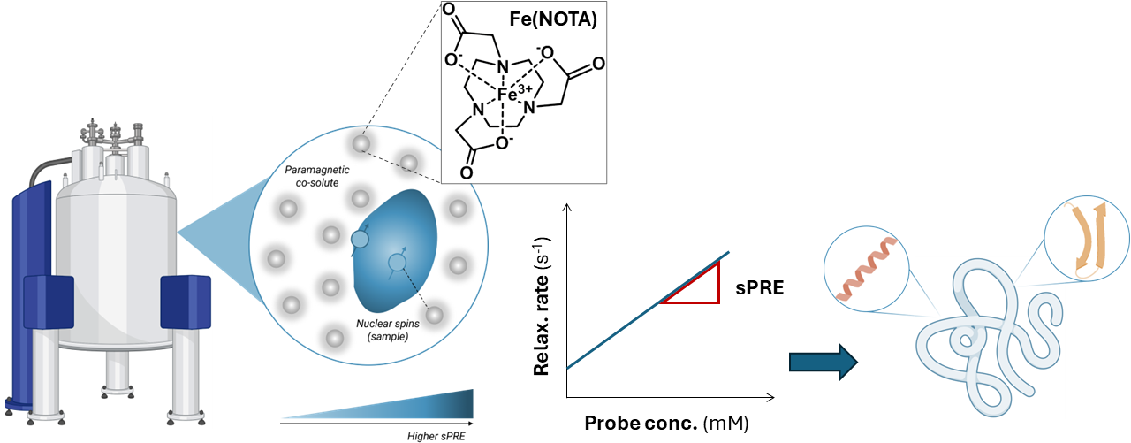
Fig. 1. Schematic representation of NMR sPRE experiments acquisition and interpretation

References
[1] E. Spreitzer, S. Usluer, and T. Madl J. Mol. Biol. 432(9), 2949–2972 (2020)
[2] M. Botta, C. F. G. C Geraldes, L. Tei WIREs Nanomed. Nanobiotechnol. 15(2), e1858 (2023)
[3] S. Chen, L. An, S. Yang Molecules 27, 4573 (2022)

Acknowledgements
This work was supported by the CERM/CIRMMP center of Instruct-ERIC (ITACA.SB project) and by the Italian Ministry for University and Research (MUR) through the PRIN 2022 (2022EMZJL4) project and the Italian Ministry of Health project PAN-HUB (2021-T4-AN-07).

