NDTA : Novel DiaCEST Agent with Strongly Shifted Exchanging Protons
Madalina Ranga,¹ Mai T. Huynh,² Sara Chirayil,² Janaka Wansapura,² Elena Vinogradov,³ Xiaodong Wen,² Mariangela Boccalon,² Zsolt Baranyai,² Zoltan Kovacs¹
¹ CRB Trieste, Bracco Imaging Spa, AREA Science Park, 34149 Basovizza (TS), Italy
² Advanced Imaging Research Center, UTSW Medical Center, Dallas, TX, United States
³ Department of Radiology, UTSW Medical Center, Dallas, TX, United States

Magnetic resonance imaging can be achieved through the chemical exchange saturation transfer (CEST) mechanism, which requires two proton pools with distinct NMR chemical shifts. CEST agents contain exchangeable protons, such as amide, amine, or hydroxyl groups, whose resonance frequencies are sufficiently separated from water to enable selective RF irradiation. When a frequency-specific saturation pulse is applied at the resonance of the small pool under slow exchange conditions (k_{ex} ≤ Δω), saturated spins transfer to water protons via chemical exchange processes by reducing the bulk water signal and producing negative contrast. Unlike traditional MRI contrast agents that depend on direct relaxation effects, CEST monitors the large bulk water signal (concentration ~40–50 mM in vivo), providing enhanced sensitivity and the ability to detect the physico-chemical properties of their environment, such as pH and temperature^{[1]}.
In diamagnetic systems, –NH and –OH exchangeable protons exhibit limited chemical shift separation (Δω = 1–4 ppm) and often overlap with endogenous labile proton pools—making selective irradiation challenging. Moreover, biological tissues produce a broad magnetization transfer (MT) background (±100 ppm), with an asymmetric component near water that complicates the quantification of CEST. Since this asymmetry decreases beyond 10–12 ppm, agents with highly shifted exchangeable protons (Δω > 12 ppm) offer better selectivity and less MT interference^{[2]}. Although paraCEST agents can achieve such a large shifts, metal-based compounds are not viable at clinically relevant CEST imaging doses^{[3]}. This project introduces a novel DiaCest agent: NDTA, which combines a large Δω with near-optimal k_{ex} for in vivo imaging at clinical 3T magnetic field.
1,8-Diaminonaphthalene tetraacetic acid (NDTA) was synthesized from commercial precursors (1,8-diaminonaphthalene). The signal of the highly shifted labile proton was easily observable in water at around 17.2 ppm (Figure 1).
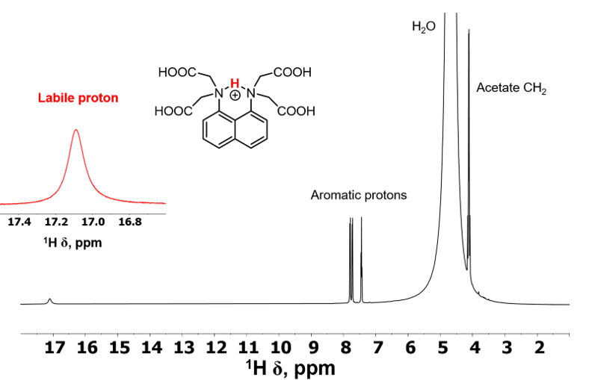
Figure 1 ¹H NMR spectrum of NDTA at pH=7.07 and 293 K in 0.15 M NaCl aqueous solution.

The k_{ex} was determined by ¹H NMR spectroscopy by using DANTE pulse train with selective inversion transfer between the exchanging pools ^{[4]}. The z-magnetization data obtained in the pH range 4 – 10 and in the tempetraute range 273 – 310 K were used to calculate the longitudinal relaxation times and the exchange rates of protons. The forward exchange rate (k_{ex}) was found to be 208 and 492 s⁻¹ at 298 and 310 K, respectively. Protonation and the formation of the most important endogenous metal complexes (Ca(II)-, Zn(II)- and Cu(II)-complexes) were studied with pH-potentiometry, ¹H NMR spectroscopy and UV-Vis spectrophotometry. The first two protonation steps of NDTA (logK₁^{H} = 10.75(2) and logK₂^{H} = 4.84(5)) were assigned to the two nitrogens while the rest (logK₃^{H} = 4.00 (5), logK₄^{H} = 3.15 (5), and logK₅^{H} = 1.70(5)) were associated to the acetate carboxylates at 25°C in 0.15 M NaCl solution. The thermodynamic stability of the Ca(II)-, Zn(II)- and Cu(II)-complex with NDTA was found to be logK_{CaL} = 5.68 (6), logK_{ZnL} = 13.33 (2) and logK_{CuL} = 17.72 (2) (25°C, 0.15 M NaCl). CEST spectra were acquired on 600 MHz/400 MHz Varian/Agilent NMR spectrometers by measuring the bulk water signal after a selective saturation pulse (B₁ = 1–10 µT, t_{sat} = 3–5 s), with a 5 s repetition time and 1 s acquisition time. The CEST effect of NDTA at pH 7 shows linear dependence with concentration, with optimal conditions at 37 °C and B₁ = 3 µT (consistent with k_{ex} = 2πB₁). In the absence of Ca²⁺ ion, CEST was pH-independent between 6–9. However, in the presence of Ca²⁺ ion, the CEST signal reflected the equilibrium Ca²⁺+ HL ⇌ CaL + H⁺. The Ca(II) complex itself showed no CEST due to the lack of exchangeable protons. At pH<8, partial dissociation of the Ca(II)-complex increased the CEST signal by shifting the equilibrium toward the release of HL. Phantom imaging showed that NDTA is about three times more effective than the gold-standard diaCEST agent, salicylate ^{[5]}, at B₁ = 3 µT, a saturation power compatible with human use. In vivo CEST imaging was performed on a Bruker BioSpec 3T small-animal MR scanner.CEST images were acquired using a single-shot RARE sequence. Z-spectra were recorded in the ±25 ppm range using a B₁ power of 2 to 5 μT. In vivo imaging following a 1 mmol/kg tail vein injection revealed renal elimination and bladder accumulation (Figure 2 ).
Figure 2 A) Phantom imaging with NDTA (at 12.5 ppm) and salicylate (at 9.6 ppm), under identical conditions (pH 7.4, 37°C, RARE, tsat = 5 s, B0 = 3T, B1 = 3µT, TR = 3 s, TE = 40 ms). B) In vivo CEST imaging in mice with NDTA at 9.4T and 3T. Dose: 200 µL, 150 µ

In conclusion, the favorable CEST properties of NDTA arise from its unique structure. Monoprotonation of 1,8-dialkylamino naphthalenes forms a highly stable intramolecular [N–H–N]⁺ hydrogen bridge, causing an extreme downfield shift of the slowly exchanging proton. The acetate sidearms enhance k_{ex} via intramolecular catalysis of the proton exchange. Additionally, NDTA forms a weak Ca(II)-complex whose pH-dependent formation/dissociation imparts pH sensitivity to the CEST effect. The new diaCEST agent NDTA combines large Δω and nearly optimal k_{ex} for in vivo imaging at clinical B₀ field.

References :
[1] G. Liu, X. Song, K. W. Y. Chan, M. T. McMahon, “Nuts and bolts of chemical exchange saturation transfer MRI” NMR in Biomedicine 2013, 26, 810–828.
[2] E. Vinogradov, A. D. Sherry, R. E. Lenkinski, “CEST: From basic principles to applications, challenges and opportunities” Journal of Magnetic Resonance 2013, 229, 155–172.
[3] S. Viswanathan, Z. Kovacs, K. N. Green, S. J. Ratnakar, A. D. Sherry, “Alternatives to Gadolinium-Based Metal Chelates for Magnetic Resonance Imaging” Chem. Rev. 2010, 110, 2960–3018.
[4] R. Freeman, G. A. Morris, “The ‘DANTE’ experiment” Journal of Magnetic Resonance 2011, 213, 244–246.
[5] X. Yang, X. Song, Y. Li, G. Liu, S. Ray Banerjee, M. G. Pomper, M. T. McMahon, “Salicylic Acid and Analogues as diaCEST MRI Contrast Agents with Highly Shifted Exchangeable Proton Frequencies” Angew Chem Int Ed 2013, 52, 8116–8119.

