Chapter 6

Ethnobotany of Medicinal Plants from High Mountains: The Case Study of Lombardy (Italy)

Claudia Giuliani^{1,2}, Fabrizia Milani^{1,2,*}, Martina Bottoni^{1,2}, Lorenzo Colombo^{1,2}, Paola Sira Colombo^{1,2}, Piero Bruschi³, Gelsomina Fico^{1,2}

¹Department of Pharmaceutical Sciences
University of Milan,
Via Mangiagalli 25, 20133
Milan, Italy
²Botanical Garden G.E. Ghirardi
Department of Pharmaceutical Sciences
University of Milan
Via Religione 25, 25088
Toscolano Maderno (BS), Italy
³Department of Agricultural, Environmental, Food and Forestry Science and Technology
University of Florence
Piazzale delle Cascine 18, 50144
Florence, Italy

*Correspondence: fabrizia.milani@unimi.it

Abstract

Ethnobotanical research in Alpine regions, especially in Lombardy (Northern Italy), has undergone a noticeable process of evolution from different points of view. This chapter guides the reader in this evolutionary path through the analysis of the ethnobotanical investigations published in this region in the last 15 years. Special attention is paid to two aspects of ethnobotany: the analysis and presentation of the primary data as a useful tool for selecting target species for the subsequent phytochemical and pharmacological research and the description of the last and often neglected phase of a survey, namely the return to the territory and its population with the thorough dissemination of the scientific results.
Through the critical analysis of the current scientific literature in the ethnobotanical field and the proposal of specific examples based on the investigations conducted in Lombardy, this journey unfolds along these two parallel tracks to finally merge in the cyclic course of ethnobotany, in which scientific research goes forward and looks to the future, starting from the traditions of a territory and returning to the same territory, ever moving, ever evolving, never forgetting its roots.

Keywords: Ethnobotany, Lombardy, North of Italy, Primary Data, Return to the population, Evolution
Chapter 6

Ethnobotany of Medicinal Plants from High Mountains: The Case Study of Lombardy (Italy)

Claudia Giuliani, Fabrizia Milani, Martina Bottoni, Lorenzo Colombo, Paola Sira Colombo, Piero Bruschi, Gelsomina Fico

6.1 Ethnobotany as tool to protect the biocultural diversity of Alpine areas
The unique intertwining of several factors, such as climatic heterogeneity, geographical and topographical variety, and isolation, is what has since always characterized the Sub-Alpine and Alpine biomes around the World, from the Europeans Alps to the Rocky Mountains of North America and the Andes in South America, and facilitated the development of its peculiar floristic and faunistic biodiversity (Inouye 2020; Verrall and Pickering 2020). Unfortunately, this richness is as extraordinary as it is extremely fragile. The climate crisis we are currently experiencing, with the rising temperatures, declining snowfall, melting glaciers, and consequent shifts of seasonal cycles, poses a direct threat on indigenous Alpine plant species and their pollinators (Inouye 2020; Verrall and Pickering 2020), and is counted among the many factors that lead to the ever increasing presence of alien invasive species in Alpine areas (Carboni et al. 2018), to the extent of altering the entire ecosystem stability.
Furthermore, the inevitable bond that humans create with the natural environment in which they are immersed cannot be dismissed. For example, human beings have learned long ago how to benefit from the plants, how to use them in different aspects of their every-day lives. They have the possibility to forge a traditional knowledge that is naturally and inevitably influenced by the plant species that they can find around them and their seasonality (Kupika et al. 2019). At the same time, human activities themselves, as well as the abrupt lack thereof, can mold the surrounding environment. For instance, on one side the indiscriminate use of plant species might be cause for their endangerment, but on the other the connection between humans and territory is so deep rooted that the abandonment of lands, especially in mountainous, sub-Alpine, and Alpine areas, might influence the ecosystem stability of a territory (i.e., by facilitating the advance of alien species) (Carboni et al. 2018). This relationship is like an ongoing loop: if it is true that the diversity of plant species of a territory influences the development of a richer ecological knowledge, it is equally true that to lose plant species would also mean to lose the traditions associated with them. As an outcome, to lose this knowledge, which is already in danger due to its declining oral transmission, would mean for a territory and its inhabitants to lose a significant portion of their identity.

Furthermore, species that have been traditionally used for medicinal purposes for centuries are reservoir of potential active compounds, ready to be studied. If we consider the high variety of medicinal plant species that can be found in mountainous areas and the traditional therapeutic uses associated with them, the loss of local knowledge might translate into loss of these potential active compounds as well (Dutfield 2010; Balick and Cox 2021).
Ethnobotany, as ‘the study of the interactions between plants and people, including the influence of plants on human culture’ (Balick and Cox 2021), has been proven to be a pivotal tool to study, enhance, and preserve the traditional uses of spontaneous and cultivated species of a territory for different purposes: i.e., medicinal, veterinary, culinary, domestic, religious, artisanal, etc. Ethnobotanical surveys can thus help staunch the erosion of traditional knowledge and the loss of cultural diversity, as well as protect the plant biodiversity of a territory (i.e., by raising awareness concerning the use of protected species, educating younger generations, preserving and maintaining species, etc.) and the potential scientific research development that comes with it.
For these reasons, particular effort must be made in ethnobotanical research in Alpine territories. Taking into consideration the European Alpine and trans-Alpine regions, some field works could be found especially in Switzerland (Abbet et al. 2014; Dal Cero et al. 2014; Disler et al. 2014; Cero et al. 2015; Mayer et al. 2017; Stucki et al. 2019; Mertenat et al. 2020; Poncet et al. 2021) and in Austria (Schunko et al. 2012; Grasser et al. 2016), but also at the border among Croatia, Slovenia, and Italy (Pieroni and Giusti 2009). Concerning the Italian Alps, ethnobotanical surveys were conducted in Liguria (Cornara et al. 2014), Piedmont (Bellia and Pieroni 2015; Fontefrancesco and Pieroni 2020; Sulaiman et al. 2024), Valle D’Aosta (Danna et al. 2022), and Trentino Alto Adige (Cavalloro et al. 2022; Mattalia et al. 2023). Finally, considering the Alpine valleys of the Lombardy region, focus of this work, one ethnobotanical investigation was performed in the province of Brescia, specifically in Valvestino (Vitalini et al. 2009), while 9 throughout the province of Sondrio, in Val San Giacomo (Vitalini et al. 2013), Valfurva (Dei Cas et al. 2015), Parco dello Stelvio (Vitalini et al. 2015), Valtellina (Bottoni et al. 2022b), and Valmalenco (Bottoni et al. 2020, 2022a, 2024; Milani et al. 2023, 2024) (Fig. 6.1).
The aim of the work presented herein is to guide the readers through an evolutionary journey in the ethnobotany of Alpine Lombardy, from the first survey published in 2009 to the most recent works. The focus will be on two key elements that can illustrate this evolution: 1) the presentation and analysis of the primary data for the selection of target medicinal species for further examinations and 2) the effort put in place to return the scientific results to the investigated territory, with important practical and economic implications.

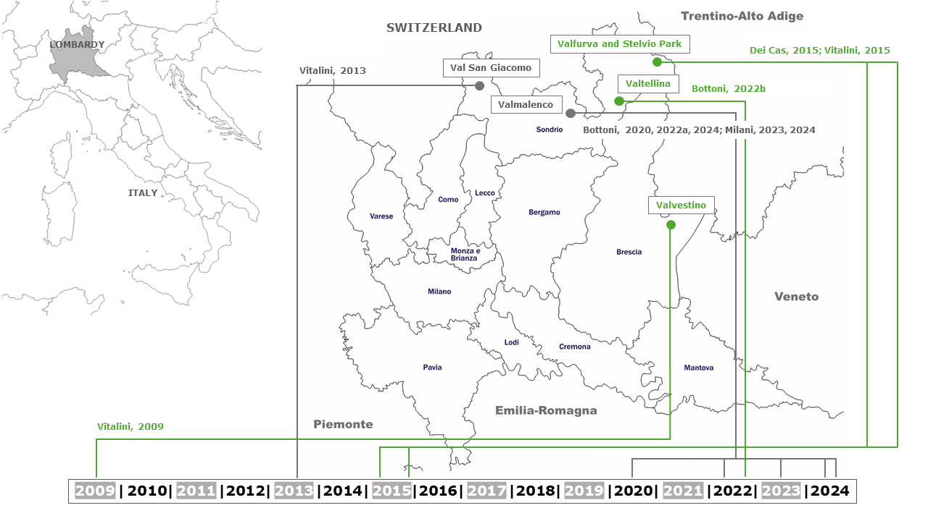
Fig. 6.1: Study area and timeline of the different investigations conducted on the Alpine territories of the Lombardy region (North of Italy)

6.2 Ethnobotany of medicinal species in Lombardy: an evolving path
As mentioned in paragraph 6.1, ethnobotanical research in Lombardy, and specifically along the Alpine territory, has been widely developed in the last 15 years, with 10 works published between 2009 and 2024. This development is highlighted not only by the increasing number of papers, but also by the undergoing process of evolution that can be observed while analyzing the concerning literature. In fact, taking into account the works cited before, some common features can be found, along with some variations and integrations that characterized a journey meant to elevate ethnobotanical investigations to pivotal tools for the preservation and strong valorization of the traditional knowledge of a territory, as well as for the undertaking of in-depth phytochemical and pharmacological analyses on medicinal plant species intrinsically linked to and inextricably guided by said traditional knowledge.

Specifically, Vitalini et al. 2009, 2013, 2015, Dei Cas et al. 2015, Bottoni et al. 2020, 2022b, and Milani et al. 2024 described only the field phase of an ethnobotanical investigation, with the subsequent analyses of the data, focusing on different sectors of use of spontaneous and cultivated plant species of the territory, with particular attention to the medicinal, veterinary, and culinary uses. The remaining works presented the field phase as a starting point for the further in-depth analysis of a single or few selected species from a micromorphological, phytochemical, nutritional, and pharmacological point of view (Table 6.1).

Table 6.1: Break down of the ten ethnobotanical investigations published in Alpine Lombardy from 2009 to 2024
Title, Authors, Year, Journal | Area of study and (Province) | Number of informants | Type of sampling and interviews | Fields of use | Number of species (botanical families) | Projects | Strategies for the return to the population phase
Traditional uses of medicinal plants in Valvestino (Italy).  Vitalini S., Tomè F., Fico G.  2009  Journal of Ethnopharmacology | Valvestino (BS) | 54 (45-94 years old) | Snowballing  Open interviews  Audio recordings | Medicinal  Some information also on Food and Veterinary | 58 (30) | Leader Plus Program 2000-2006  To promote in a sustainable way the local endogenous potential of peripheral rural areas | Ex situ preservation of some of the species at the ‘G.E. Ghirardi’ BG
Traditional knowledge on medicinal and food plants used in Val San Giacomo (Sondrio, Italy) – An alpine ethnobotanical study.  Vitalini S., Iriti M., Puricelli C., Ciuchi D., Segale A., Fico G.  2013  Journal of Ethnopharmacology | Valle San Giacomo (SO) | 104 (35-89) | Snowballing  Open interviews  Audio recordings (only for group interviews) | All the fields | 66 (35) | Projects linked to MU.VI.S (Museo della Via Spluga e della Val San Giacomo).  To promote spontaneous species | Not specified
Tradition of use on medicinal species in Valfurva (Sondrio, Italy).  Dei Cas L., Pugni F., Fico G.  2015  Journal of Ethnopharmacology | Valfurva (SO) | 92 (23-97) | Snowballing  Semi structured interviews  Audio recordings | All the fields | 126 (48) | No | Not specified
Plants, people and traditions: ethnobotanical survey in the Lombard Stelvio National Park and neighbouring areas (Central Alps, Italy).  Vitalini S., Puricelli C., Mikerezi I., Iriti M.  2015  Journal of Ethnopharmacology | Stelvio National Park (SO) | 328 (28-88) | Snowballing | All the fields | 192 (65) | No | Not specified
Using Medicinal Plants in Valmalenco (Italian Alps): From Tradition to Scientific Approaches.  Bottoni M., Milani F., Colombo L., Nallio K., Colombo P.S., Giuliani C., Bruschi P., Fico G.  2020  Molecules | Valmalenco – Municipality of Caspoggio (SO) | 137 | Snowballing  Open interviews | Medicinal and veterinary | 59 (30) | Interreg Italy/Switzerland B-ICE&Heritage | Yes (but not specified in the paper)
Alpine ethnobotanical knowledge in Sondalo (SO, Lombardy, Italy)  Bottoni M., Colombo L., Gianoli C., Milani F., Colombo P.S., Bruschi P., Giuliani C., Fico G.  2022  Ethnobotany Research & Applications | Sondalo (Valtellina, SO). | 101 (25-98 anni) | Snowballing  Open interviews | All the fields | 112 (52) | No | No
Achillea moschata Wulfen: From Ethnobotany to Phytochemistry, Morphology, and Biological Activity.  Bottoni M., Baron G., Gado F., Milani F., Santagostini L., Colombo L., Colombo P.S., Caporali E., Spada A., Biagi M., Giuliani C., Bruschi P., Aldini G., Fico G.  2022  Molecules | Valmalenco – Municipality of Chiesa in Valmalenco (SO) | 125 (18-96) | Snowballing  Open interviews | Medicinal | 148 | Interreg Italy/Switzerland B-ICE&Heritage | Yes (but not specified in the paper)
Alpine Diet in Valmalenco (Lombardy, Italy): Nutritional Features of Spontaneous Plants and Traditional Dishes.  Milani F., Bottoni M., Giuliani C., Colombo L., Casiraghi M.C., Colombo P.S., Bruschi P., Erba D., Fico G.  2023  Nutrients | Valmalenco – All 5 municipalities (SO) | 401 (11-95) | Snowballing  Open interviews | Food | 154 (54) | Interreg Italy/Switzerland B-ICE&Heritage and GEMME projects | Yes (but not specified in the paper)
From Primary Data to Ethnopharmacological Investigations on Achillea erba-rotta subsp. moschata (Wulfen) I.Richardson as a Remedy against Gastric Ailments in Valmalenco (Italy).  Bottoni M., Martinelli G., Maranta N., Sabato E., Milani F., Colombo L., Colombo P.S., Piazza S., Sangiovanni E., Giuliani C., Bruschi P., Vistoli G., Dell'Agli M., Fico G.  2024  Plants | Valmalenco – All 5 municipalities (SO) | 401 (11-97) | Snowballing  Open interviews | Medicinal, Food, Veterinary | Only Achillea erba-rotta subsp. moschata | Interreg Italy/Switzerland B-ICE&Heritage and GEMME projects | Yes (but not specified in the paper)
Beyond the Border: comparative ethnobotany in Valmalenco (SO, Italy) and Valposchiavo (Canton of Grisons, Switzerland).  Milani F., Bottoni M., Colombo L., Colombo P.S., Bruschi P., Giuliani C., Fico G.  2024  Journal of Ethnobiology and Ethnomedicine | Valmalenco – All 5 municipalities (SO) + Valposchiavo – All 3 municipalities (Canton of Grisons, SW) | 401 Valm/70 Valp | Snowballing  Open interviews | All the fields | Valm 227 (77); Valp 226 (65) | Interreg Italy/Switzerland B-ICE&Heritage and GEMME projects | Yes (but not specified in the paper)

Vitalini et al. 2009 – Valvestino (BS)

The survey presented in Vitalini et al., 2009 was conducted in Valvestino, a fairly isolated Alpine valley in the province of Brescia, as part of the 'LEADER 2000-2006 Lombardy Region’ project, aimed at promoting and sustaining fringe rural areas. The ethnobotanical investigation meant to abide by these goals through the valorization of traditional knowledge concerning plant species and the study of intergenerational transfer. Additionally, an attempt at preserving some of the plant species surfaced during the survey was made ex situ at the ‘G.E. Ghirardi’ Botanical Garden in Toscolano Maderno, Brescia (Department of Pharmaceutical Sciences, University of Milan).
The work was developed into three main phases: a) preliminary study of the flora, with the collection of photographs and herbarium specimens of the plants; b) open interviews conducted on 54 informants (45-94 years old); c) basic data analysis and browsing of the scientific literature in order to evaluate the traditional uses collected. From the survey, the uses of 58 species (belonging to 30 botanical families) were reported, mainly concerning the medicinal field.

Vitalini et al. 2013 – Val San Giacomo (SO)

This work, conducted in Val San Giacomo (province of Sondrio) was loosely linked to the MU.VI.S, Museo della Via Spluga e della Val San Giacomo (Museum of Via Spluga and Val San Giacomo), in the effort of valorizing and preserving the spontaneous flora of the territory through the restoration of traditional knowledge. In 2013, the ethnobotanical landscape in Lombardy, specifically on the Alps, could have been described as fragmentary compared to what was published in Central and Southern Italy, so that this survey was considered one of the first attempts at enriching and expanding it. Just as for Vitalini et al., 2009, the pre-field and field phases of the survey were conducted in a similar manner, with a focus on all the fields of use of plants, whilst the data analysis steered towards a more quantitative approach. In fact, the authors used an extensive number of ethnobotanical indices and then accompanied the results with what information could be found in scientific literature regarding the medicinal uses. One hundred and four informants (35-89 years old) were involved in the survey, with a total of 66 species mentioned (35 botanical families), mainly by elderly people.

Dei Cas et al. 2015 – Valfurva (SO)

This work, conducted in Valfurva in the province of Sondrio, was not part of a wider project but it should be highlighted that one of the authors was native to the area of study and that the survey itself originated by their strong wish to deepen their own understanding of the folk traditions of the territory and to value them. The area belongs in its entirety to the Stelvio National Park, where a strict regulation on the collection of spontaneous plants is maintained. The first phase of the survey was carried out as in the previous works cited, while semi-structured interviews were conducted during the field phase involving 92 informants (23-97 years old). The approach to the pool of respondents was definitely eased by the constant presence on the territory of a native researcher. The analysis of the dataset was performed through the calculation of a more limited number of ethnobotanical indices. Though all the fields of use were considered, 91 species were used for medicinal purposes and the bibliographic research highlighted scientific studies conducted on 41 out of these. Among the medicinal species cited, Achillea erba-rotta subsp. moschata (Wulfen) I.Richardson, the use of which had already been mentioned in Val San Giacomo, turned out to be known and used by the whole pool of informants in the medicinal, veterinary, and food fields.

Vitalini et al. 2015 – Stelvio National Park (SO)

The study area of this survey was the Stelvio National Park, in the province of Sondrio, an Alpine territory that includes the municipalities of Bormio, Livigno, Sondalo, Valdidentro, Valdisotto, and Valfurva. Given the broader territory, a total number of 328 informants (28-88 years old), both native to the area and resident for at least 15 years, was involved in semi-structured interviews. As in Vitalini et al., 2013, a large number of different ethnobotanical indices was used for the quantitative analysis of data concerning 192 species (65 families and 149 genera). The authors also stressed the importance of ethnobotanical surveys of this kind in the discovery process of potentially active compounds obtained from spontaneous medicinal species, especially in a territory as rich in biodiversity as the Alpine range, and provided extensive bibliographic research meant to preliminarily validate the traditional uses.

Bottoni et al. 2020 – Caspoggio, Valmalenco (SO)

The work presented in Bottoni et al., 2020 was the first of a series of papers published on the ethnobotanical survey conducted in Valmalenco (province of Sondrio) as part of the European Interreg Italy-Switzerland B-ICE & Heritage and the subsequent Interreg GEMME projects. These two projects covered a period of time of 5 years (2018-2023) and were aimed at the sustainable development of the environmental and cultural resources of a territory threatened by the ongoing climate crisis in order to create new opportunities of tourism attractiveness. In Bottoni et al., 2020, the authors presented the partial results of the investigation, concerning the medicinal and veterinary uses in one of the municipalities of the valley, Caspoggio. In addition to the phases already described in the previous works, in this paper special attention was given to the comparison of species and traditional uses recorded in Caspoggio and the ones reported in the neighboring areas. Furthermore, a clear example of preliminary validation of traditional use was given not only through the presentation of the bibliographic research collected on the ethnobotany, phytochemistry, and pharmacology of each species, but also with considerations on the types of extracts described in literature and comparable to the traditional preparations of the valley. Finally, a box was specifically dedicated to the case of Pinus mugo Turra, which was one of the most cited plants. The box unfolded through the evaluation of phytochemical and pharmacological investigations previously published on this species, in order to highlight its potential activities in the treatment of upper airways ailments.

Bottoni et al. 2022a – Chiesa in Valmalenco, Valmalenco (SO)

This work proposed the ethnobotanical results obtained from the interviews conducted on 125 informants (18-95 years old) in Chiesa in Valmalenco, as part of the Interreg project described in the previous paragraph on Bottoni et al. 2020. Specifically, the medicinal field was the main focus of the paper, and the survey could be considered the starting point from which underlining the importance of the traditional use of A. erba-rotta subsp. moschata in the treatment of digestive problems. The multidisciplinary laboratory investigation that stemmed from the field phase described, developed through micromorphological observations of the species collected during its balsamic time, according to the tradition of the valley, phytochemical LC-MS/MS analyses on aqueous extracts from dried flowerheads, and in vitro evaluations regarding the antioxidant and anti-inflammatory activity of the same extracts.

Bottoni et al. 2022b – Sondalo (SO)

As it happened in Dei Cas et al., 2015, the survey conducted in Sondalo (province of Sondrio) was not a part of a wider project, but it stemmed from the thesis work of one of the authors, native to the study area. Sondalo is located in the heart of the Stelvio National Park, in the territory of upper Valtellina. The structure of the work followed some of the previous surveys, such as Dei Cas et al., 2015 and Bottoni et al., 2020, focusing on all the use fields, from the medicinal to the artisanal, through the domestic, food, veterinary, ludic, and religious. A total of 112 plant species (52 families) were mentioned by the 101 informants interviewed (25-98 years old). The phase of data analysis developed through the calculation of only two ethnobotanical indices, which were mainly aimed at evaluating the consensus among the 101 respondents concerning the use of medicinal species.

Milani et al. 2023 – Valmalenco (SO)

The ethnobotanical results on the food field of use were the main focus of the survey phase presented in Milani et al., 2023. In fact, based on the data obtained from the entire pool of informants (n=401) 6 spontaneous edible species were selected among the most mentioned and subsequently analyzed regarding their nutritional features, such as their proximate composition and minerals concentration, the content in total polyphenols and the total carotenoids. Specifically, the selected species were Aruncus dioicus (Walter) Fernald (young sprouts, raw and cooked), Chenopodium bonus-henricus L. (leaves, raw and cooked), Rumex acetosa L. (leaves and young stems, raw), Silene vulgaris (Moench) Garcke (leaves, raw and cooked), Taraxacum officinale Weber (leaves, raw and cooked; leaves, flowerheads, and roots, raw), and Urtica dioica L. (leaves, raw and cooked). Furthermore, nutritional analysis on traditional recipes, green gnocchi with U. dioica or C. bonus-henricus, were carried out in order to evaluate the in vitro effect of the presence of the vegetable ingredients on the starch digestibility. This represents one of the few works that captured the nutritional value of species collected in the Alps and of plant-based typical dishes of the area.

Bottoni et al. 2024 – Valmalenco (SO)

Like in Bottoni et al., 2022b, in the framework of the European Interreg Italy–Switzerland B-ICE & Heritage project, the laboratory investigation described in this 2024 paper stemmed from the description of the field phase conducted on the entire territory of Valmalenco, specifically focusing on the species A. erba-rotta subsp. moschata and its traditional use for the treatment of digestive problems, such as dyspepsia. The chosen approach involved the presentation of the raw primary data instead of focusing on the use of indices, for example by reporting sentences directly recorded from the informants. Special attention was given to the evaluation of the anti-inflammatory potential at gastrointestinal level of the traditional decoction of flowerhead. Moreover, the concentration-dependent inhibition of H. pylori growth and the anti-adhesive effect of the same extracts were assessed. Finally, the bitter taste of the aqueous preparation was investigated through molecular docking techniques.

Milani et al. 2024 – Valmalenco (SO)

As final step of the European Interreg Italy–Switzerland Gemme project, the ethnobotanical results regarding every field of use, recorded throughout the entire territory and on the entire pool of informants (n=401 in 2019-2022), were presented in this paper alongside their comparison to the ones obtained in 2023 the neighboring Swiss valley of Valposchiavo (number of informants = 70). The qualitative and quantitative comparison between the two valleys were then enriched by the one with the published ethnobotanical literature concerning both the Italian and Swiss neighboring valleys.

6.2.1 Overview of the main results

The studies were conducted on individuals ranging from 60 to 401 in number, most of which were elderly. Asteraceae turned out to be the most cited botanical family in all of the studies considered, while other families commonly mentioned were Lamiaceae and Rosaceae. As for the plant species, 146 were cited in at least two areas, while it is interesting to highlight that 16 species were commonly cited along all the territories considered, specifically Abies alba L., A. erba-rotta subsp. moschata, Achillea millefolium L., Arnica montana L., Artemisia absinthium L., Hypericum perforatum L., Juniperus communis L., Larix decidua Mill., Matricaria chamomilla L., Melissa officinalis L., Pinus mugo Turra, Plantago major L., Rosa canina L., Sambucus nigra L., Taraxacum officinale Weber, and U. dioica In terms of traditional medicinal uses, A. montana and A. erba-rotta subsp. moschata were among the most relevant species throughout the entire area, especially in the medicinal sector of use. A. montana was deemed a useful remedy for muscle-skeletal problems, whereas A. erba-rotta subsp. moschata was mentioned in Valfurva and Valmalenco for digestive purposes, but also as a hemostatic agent and in wound healing, or as an analgesic and expectorant, as well as for veterinary purposes (Dei Cas et al. 2015; Bottoni et al. 2020, 2022b; Milani et al. 2024). In Val San Giacomo and in Valtellina, for example, it was mainly known for its digestive properties (Vitalini et al. 2013; Bottoni et al. 2022b).

The ‘exclusive’ species are also worth mentioning. In fact, while in the majority of these ethnobotanical surveys the number ranges from 4 to 26, a total of 64 plant species were cited exclusively during the investigation conducted on the territory of Stelvio National Park (Vitalini et al. 2015). This higher number might be attributable to the wider territory examined in the work. However, despite the high number of exclusive species in this paper, if we consider the medicinal sector, the area of Stelvio National Park has one of the highest levels of similarity, according to the Jaccard’s Indices in Table 6.2, specifically with Valfurva (JI=0.40). A JI of 0.40 was also found between Valfurva and Val San Giacomo and, interestingly enough given the different provinces, between Val San Giacomo and Valvestino. On the other hand, it is quite striking that the lowest similarity (JI=0.21) was found between the Stelvio Park and Sondalo, considering that Sondalo is actually part of the park itself. Overall, the JI (range 0.21-0.40/1.00) are rather low considering that some of the areas described in the papers non only border, sometimes they even overlap.
These discrepancies may be justified by the challenge of comparing datasets belonging to different works published over the years (a span of 15 years, in this specific case). Nonetheless, this might also represent further evidence of the high heterogeneity and depth of the traditional knowledge of the Alpine area.

Table 6.2: Jaccard’s Similarity Index calculated, according Pitaman et al., 2005, for the medicinal uses in the different areas considered. JI values may range from 0 to 1, where 1 represents the highest level of similarity between two areas.

 | Valvestino | Val San Giacomo | Valfurva | Stelvio Park | Sondalo | Valmalenco
 | Vitalini et al. 2009 | Vitalini et al. 2013 | Dei Cas et al. 2015 | Vitalini et al. 2015 | Bottoni et al. 2022a | Bottoni et al. 2020 and Milani et al. 2024
Valvestino | 1.00 | 0.40 | 0.29 | 0.26 | 0.26 | 0.26
Valle San Giacomo | 0.40 | 1.00 | 0.40 | 0.28 | 0.30 | 0.26
Valfurva | 0.29 | 0.40 | 1.00 | 0.40 | 0.33 | 0.27
Stelvio Park | 0.26 | 0.28 | 0.40 | 1.00 | 0.21 | 0.28
Sondalo | 0.26 | 0.30 | 0.33 | 0.21 | 1.00 | 0.35
Valmalenco | 0.26 | 0.26 | 0.27 | 0.28 | 0.35 | 1.00

6.2.2 Ethnobotanical indices: just a whim or actually useful?

One aspect of the evolution of this ethnobotanical journey in Alpine Lombardy is the analysis and presentation of the primary data. The majority of the surveys presented herein developed the field phase through the quantitative analysis of the data collected. One of the most common ways of this examination involves the use of ethnobotanical indices, according to the reference scientific literature (Table 6.3).

As can be observed in Table 6.3, in Vitalini et al. 2009 the authors chose not to calculate ethnobotanical indices in the presentation of the primary data. In fact, they opted for presenting only the number of citations/use reports. The medicinal uses of the species were then collected in a dedicated table, while the food and veterinary sectors were briefly described in the text. Overall, this kind of presentation of field data was clear and concise. Nonetheless, though the authors dedicated the introduction of the work to the importance of wild medicinal species in discovering new potential active compounds, the raw primary data didn’t seem designed to guide and support the readers and the authors themselves in selecting a species of interest for further laboratory investigations.

As diametrically opposed to this approach as it could get, we find Vitalini et al. 2013 and 2015, in which a massive use of indices could be found: Ethnophytonomic Index (EPI), Ethnobotanicity Index (EI), Relative Frequency of Citation (RCF), Relative Importance (RI), Use Value (UV), and Informant Consensus Factor (ICF) were among the selected indices. Additionally, at the end of Vitalini et al. 2013, the statistical correlation among the different indices of relative importance was calculated, along with the correlation between the number of informants and citations and the quantitative indices.

Table 6.3: Use of indices as a means to present primary data in ethnobotanical surveys along the Lombardy Alps. EPI= Ethnophytonomic Index; EI= Ethnobotanicity Index; RFC= Relative Frequency of Citation; RI= Relative Importance; UV= Use Value; ICF= Informant Consensus Factor; FL= Fidelity Level; JI= Jaccard’s Index
Index | Significance of use | Vitalini et al. 2009 | Vitalini et al. 2013 | Vitalini et al. 2015 | Dei Cas et al. 2015 | Bottoni et al. 2020 | Bottoni et al. 2022a | Bottoni et al. 2022b | Milani et al. 2023 | Bottoni et al. 2024 | Milani et al. 2024
EPI  Bonet et al., 1999 | Defines the correlation between the number of species known by their vernacular names and the number of species constituting the flora of the studied territory | - | + | + | - | - | - | - | - | - | -
EI  Portères, 1970 | Defines the correlation between the plant species with at least one known traditional use and the whole flora of the territory | - | + | + | - | - | - | - | - | - | -
RCF  Tardio and Pardo-De-Santayana, 2008 | Defines whether and how much a species is used in a territory | - | + | - | + | - | - | - | - | - | -
RI  Bennet and Prance, 2000 | Gives information on the versatility of uses for a species | - | + | - | + | - | - | - | - | - | -
UV  Phillips and Gentry, 1993; Tardio and Pardo-de-Santayana, 2008 | Defines the mean of the uses per informant for every species | - | + | - | - | - | - | - | - | - | -
ICF  Trotter and Logan, 1986 | Studies the agreement among the informants on the use of species for the treatment of an ailment | - | + | + | + | + | - | + | - | - | +
FL  Friedman, 1986 | Defines the consensus among the informants on medicinal uses | - | - | + | - | + | - | + | - | - | -
JI  Pitman et al., 2005 | Compares data of neighboring territories based on the presence/absence of the reported uses | - | - | - | - | + | - | - | - | - | +

Regarding EPI and EI, although these indices may be useful and are still calculated in most recent works (Petelka et al. 2020; Gras et al. 2021), they may also fall short when it comes to territories in which the whole pool of local flora has not been wholly mapped or has not been mapped altogether (Dei Cas et al. 2015). Moreover, in the case of EPI specifically, the number of species that are known by their vernacular names in a given territory might not automatically reflect their use and relevance in said territory (Signorini et al. 2013).

The authors proceeded to rank the first 20 species obtained by number of informants, number of citations, RFC, UV, and RI. While most of the species in the rankings were comparable, it is interesting to note that the position of many of them changed. Not only that, but for the RI ranking there were at least 7 exclusive species. The perfect correspondence between the lists obtained by number of informants and number of citations with the ones by RFC and UV, was justified by the fact that RFC and UV are actually directly proportional to number of informants and citations, respectively. The authors themselves found a strong statistical correlation between these numbers and the indices, thus ulteriorly solidifying the issue. Therefore, there seems to be no benefit in calculating two indices when the same information could be obtained by just observing the raw primary data (in this case, the simple number of informants and citations).

Moreover, basing an index, such as RI, on the variety of uses, seems furtherly confounding: species like A. erba-rotta subsp. moschata or A. montana, which are used extensively in these territories but in fewer manners, would be in lower positions in a ranking based on RI or, like in the case of A. montana in Vitalini et al., 2013, would not even be included at all.

Even ICF, which was utilized not only in Vitalini et al. 2013 and 2015, but also in the majority of the other surveys analyzed herein (Dei Cas et al. 2015; Bottoni et al. 2020, 2022b; Milani et al. 2024), and FL (Vitalini et al. 2015, Bottoni et al. 2020, 2022b) should be used carefully. In fact, these indices should disclose the consensus among the informants on medicinal uses and the agreement among the informants on the use of species for the treatment of an ailment, respectively. However, when comparing ICFs or FLs of different investigations, the problem of the comparability of different datasets must be considered, especially in the definition of citation/use report and in the classification of the different categories of pathology (apparatuses). As already mentioned, the same issue could prove to be a problem when using Jaccard’s similarity Index (JI) to compare data of neighboring territories based on the presence/absence of the reported species or uses.

Although indices such as these represented an attempt at bringing rigor to the quantitative analysis of ethnobotanical datasets, which was first defined in the 1980s (Prance et al. 1987), in recent times they have not been exempted from criticism even by some of the authors that once supported them, stating that such indices are not built upon solid statistical principles, or that many of these indices may be effectively replaced by the solid quantitative and statistical analysis of the use-reports (Verpoorte 2012; Weckerle et al. 2018; Leonti 2022).

Even from the papers discussed so far it is quite clear that the selection of medicinal species of interest to be further investigated during the laboratory phase cannot be based on the mere use of ethnobotanical indices and that, sometimes, they might even prove to be misleading. Some of the indices, such as ICF, might be useful when conveniently supported by the primary data. Not only by the number of informants or the number of citations, but also by other qualitative information that could never be translated into numbers or indices: the use of a vernacular name for a specific plant, the personal tales of every-day life thoroughly intertwined to a species, etc.

Surely, all of this must be then supported by extensive bibliographic research on the selected species or on the respective genus and botanical family and, also during the laboratory investigation, every single step must consistently guide each subsequent phase.

When the selection of a species of interest is carried out with these premises, even the limited number of informants involved in ethnobotanical investigations becomes less of a problem. With the quantitative analysis being supported by the other aforementioned elements, the analysis of new or little studied species and of their extracts, as well as the research of new active compounds may move forward. The progress of the scientific research on new plant-based active compounds is actually possible precisely thanks to the field phase of ethnobotany.

This evolution in data analysis methodologies is reflected in the most recent Valmalenco articles: Bottoni et al., 2022a, Milani et al., 2023, and Bottoni et al., 2024. Specifically, in Milani et al. 2023, the selection of 6 target species in the food sector was not performed by use of specific indices, but by considering the plants with at least 50 use-reports and the numerous local culinary recipes and samples that were collected during the infield investigation with the ever-present help and the guidance from the inhabitants of the valley. This allowed not only for the analysis of these 6 species from a nutritional point of view, but also for the assessment of nutritional features and their potential impact on human health of traditional dishes in which some of these species are the main ingredients.

Also, in both Bottoni 2022a and Bottoni 2024, the selection of A. erba-rotta subsp. moschata as a symbol species of the territory, thus slated for further investigations in a laboratory setting, was firmly based on the valorization of the raw primary data gathered during the field-work phase. This plant was specifically used against ailments typical of the gastrointestinal tract, such as stomachache, dyspepsia, gastritis, and even ulcers, alone or as support to the traditional pharmacological treatment.
Therefore, the types of analysis performed on the species were aligned with the actual traditional uses of the species and were heavily influenced by the raw data itself.

Other than by the investigation conducted in Valmalenco and described in both the papers also through the account of anecdotal evidence recorded during the field work, the traditional use of this species for the treatment of gastrointestinal ailments was confirmed by the other works conducted on the Alpine range. Furthermore, the choice was also guided by the scarce scientific literature on the species (Vitalini et al. 2016, 2022, and Argentieri et al. 2020, on the phytochemistry and biological activity; Apel et al. 2021, with the phytochemical and antimicrobial activity investigation on different species of the genus; Fusani et al. 2022, with the study on the variability in essential oil composition), which was not always based on the analysis of traditional preparations and on the validation of the traditional use.

The laboratory phases described in Bottoni et al. 2022a and Bottoni et al. 2024 developed through different steps, starting with the micro-morphological and histochemical investigations. The observation of the number and the distribution pattern of the glandular trichomes responsible for the production and secretion of active compound effectively confirmed the juxtaposition of the time of the year when the species is traditionally collected and its actual balsamic time.

This was followed by an attentive phytochemical investigation, aimed at characterizing the decoction of A. erba-rotta subsp. moschata as it is prepared by the informants themselves. The analysis was furtherly enriched by the assessment of the bitter taste of the decoction by means of molecular docking techniques. Finally, the in vitro tests that were carried out on the aqueous preparations allowed us to evaluate the different mechanisms behind its antioxidant and anti-inflammatory activities and to underline an interesting anti-bacterial and anti-adhesion activity against Helicobacter pylori.
This preliminary validation of the traditional use of the species may be just the starting point from which a 360-degree investigation could be conducted. In fact, the interest towards this species seems to have spiked in the last few years as demonstrated, other than by the papers already mentioned, by some of the most recent works on the species (Aiello and Fusani 2023, with the morphological and quantitative characteristics of five accessions of cultivated musk yarrow and Salamone et al. 2023, with the specific analysis of the non-volatile terpenoids and lipophilic flavonoids of the species). The different lines of research are really numerous and extremely interesting, especially when the centenarian tradition revolving around this species is taken as reference point.

6.2.3 “Render unto Caesar…”, even better if more is returned!

Seven out of the ten papers considered herein were part of a wider framework (Table 6.1). However, while Vitalini et al. 2009 and 2013 very briefly referred to projects aimed at enhancing rural areas through the valorization of the local flora, the investigation conducted in Valmalenco was entirely the result of the pluriannual Interreg Italy-Switzerland B-ICE & Heritage and Interreg Gemme projects (2018-2023). These were designed to enhance the Italian and Swiss Alpine valleys located at both sides of the Pizzo Bernina (4,048 m a.s.l.), specifically Valmalenco in Italy and Valposchiavo in Switzerland. Through the retrieval and preservation of the Local Ecological Knowledge revolving around traditional uses of wild plant species, we focused our efforts on finding viable alternatives to winter tourism, which is now in danger due to the evermore severe consequences of the ongoing climate crisis on snow precipitations and glaciers stability. As the important economic inflow of winter tourism is put at risk, cultural tourism might be the better alternative, since it is not bound by climate conditions but instead rooted in the local traditions (Consorzio turistico del mandamento di Sondrio https://www.sondrioevalmalenco.it/it/progetto-b-ice-heritage).

Being part of a wider project is also reflected by the possibility to dedicate part of the endeavors of an investigation to give something back to the population, be it better knowledge, more awareness, or an economic return. These concepts are all part of the Open Science methodology. After all, an ethnobotanical investigation is always deeply rooted in a territory and, as it takes its first steps among its people, it is only fair for its last steps to be taken in the same territory. Valuable local traditions shall be further enriched of scientific knowledge and return to the population, as in the cycle described in Fig. 6.2.

Fig. 6.2: Cyclic representation of an ethnobotanical survey, from the territory to the territory and its inhabitants
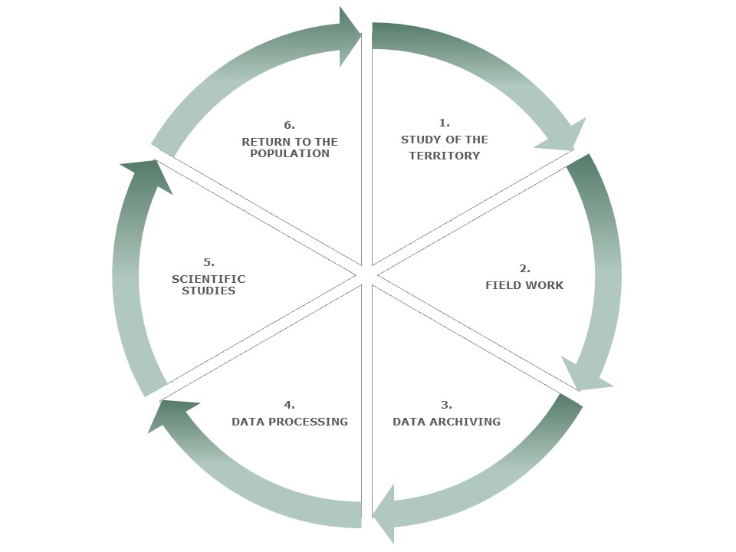

This ‘return to the population’ phase can be articulated in a variety of ways. After the investigation in Valvestino, for example, the strategy was the ex situ cultivation of some of the most relevant species selected during the field work in a dedicated flowerbed at the “G.E. Ghirardi” Botanical Garden in Toscolano Maderno (Brescia). The species were then accompanied by an ad hoc didactic and informative apparatus born from the investigation itself.

Things were different in Valfurva (Dei Cas et al. 2015) and Sondalo (Bottoni et al. 2022b). These two surveys were not part of any project but were strongly desired and supported by two of the authors, native to the two territories, who in the end dedicated their dissertations to the valorization of their own culture and traditions.

It wasn’t until a more complex and articulated project, such as the aforementioned Interreg in Valmalenco, that implementing several different return strategies became feasible, in an unprecedented effort to abide by the Open Science guidelines.

The greatest achievement in this phase was without doubts the conceptualization, design, and realization of the “E. Dioli” Botanical Garden in Sant’Antonio di Caspoggio (1,300 m a.s.l.), which was inaugurated in July 2023 (Orto Botanico “E. Dioli” 2023, https://www.ortobotanicocaspoggio.it/). As mentioned before, this territory has been severely affected by the ongoing climate change. The area of Sant’Antonio di Caspoggio, specifically, used to be a sought after ski destination up until 10 years ago, when the ski resorts were closed due to insufficient snow precipitation (Calufetti 2013).

The creation of the ‘E. Dioli’ BG represented a cultural Renaissance for the area, because it is the first high-altitude botanical garden completely dedicated to the wild plant species of a territory and their traditional uses, which were first identified during the field work phase of an ethnobotanical investigation.

The garden was named after Erminio Dioli, a local 19th century architect and artist. Additionally, the name of the garden was chosen to foster the connection with the ‘Dioli’ Museum in Caspoggio, which in turn allowed for the creation of a cultural circuit dedicated to the artist, his accomplishments, and his native territory.

Almost 100 selected plant species were arranged in 8 flowerbeds, each dedicated to a traditional sector of use. Experts were consulted in order to consider several aspects of the design of the garden, such as total extension of the area, height reached by the plants, potential species incompatibility, special needs in terms of soil, watering, and pedo-climatic characteristics, level of endangerment, and aesthetics. New illustrative panels were created (Fig. 6.3), as well as labels which identified each flowerbed through ad hoc drawings specifically designed for the garden (Fig. 6.4). Also, new labels were dedicated to the plant species providing the following information: botanical family, scientific name, common and vernacular name, botanical characters, habitat and altitudinal zone, protection, balsamic time, traditional uses identified during the field investigation, and part of the plant used (Fig. 6.5).

Fig. 6.3: Illustrative panel situated at the entrance of the ‘E. Dioli’ Botanical Garden. Designing of the logo: Fabrizio Chierichetti. Graphic design: Arch. Patrizia Berera. Original drawings: Carlo Grimoldi.
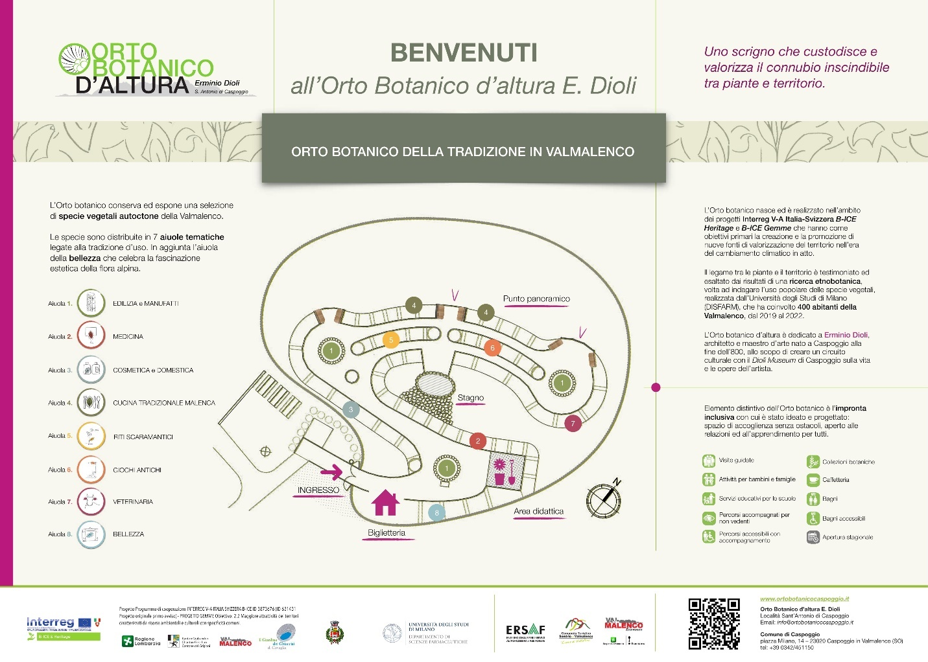
Fig. 6.4: Drawings dedicated to each flowerbeds/sector of uses: a) flowerbed of beauty; b) construction; c) medicinal; d) culinary; e) domestic and cosmetic; f) veterinary; g) ancient games and toys; h) ritualistic/religious. Original drawings: Carlo Grimoldi.
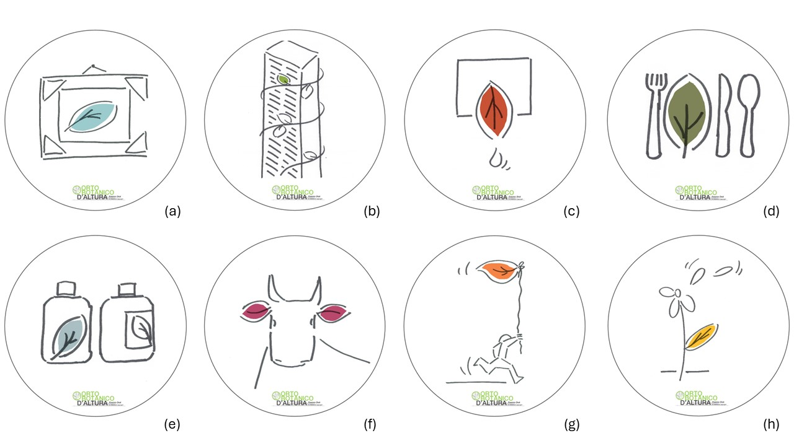

Fig. 6.5: The new labels dedicated to the plant species of the ‘E. Dioli’ Botanical Garden. Graphic design: Arch. Patrizia Berera. Original drawings: Lorenzo Colombo.
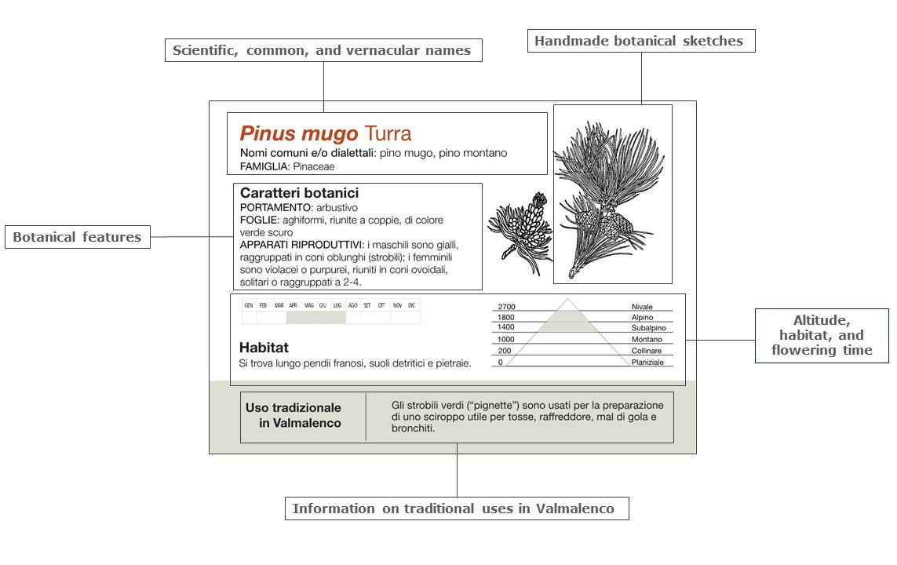
Accessibility of the spaces and sustainability of the materials used were also major concerns in the realization of the Dioli Garden. Inclusiveness is a core value of the BG, and plans have already been made to include interpretative apparatuses, which provide information in Braille, and to translate the content at least in English.

As for local resources development, and as part of a Citizen Science framework, local guide and volunteers were trained through a three-part course to manage the yearly summer opening. Along with these selected guides and other experts, weekly activities, laboratories, guides, and tours were implemented for both children and adults, with special attention to people with disabilities.

Finally, booklets for children, leaflets, bookmarks, and gadgets were created with the aid of professional illustrators, in order to help the self-support of the garden. The creation of this Garden, which is the first of its kind in Italy, would have not been possible without the active participation from the inhabitants of the valley. Needless to say, every information concerning the traditional uses of plant species came from the inhabitants themselves, but this is not where their involvement stopped: the local administrations also played a pivotal role in the realization of the project, and even the schools of Valmalenco and the neighboring valleys have begun including the laboratories and activities offered by the Garden in their educational proposals.

The creation of a botanical garden is not the only effort made in this last phase of the survey. In fact, for the past three years, an event called ‘Festival of medicinal plants’ has been held in the valley, in which the scientific results of the investigations were divulged back to the local population. Additionally, this dissemination was carried out in creative ways, such as the publication of educational booklets for both adults and children, with the extraordinary participation of illustrators and graphic designers (Fico et al. 2023a, b), the organization of various public seminars, etc.
It is thus evident that, in the framework of a cyclic ethnobotanical investigation, both the “E. Dioli” Botanical Garden and the other strategies put in place in Valmalenco could represent an effective example of Open Science concepts put into practice.

6.3 Conclusions
In the last few years, ethnobotanical research in Lombardy has evolved considerably. This progress is evident since the very first investigations performed in this region, particularly on the Alpine range. As a matter of fact, the primary objective of these first works was to fill gaps in scientific literature concerning the complex mosaic of traditional knowledge in this area, which had never been investigated before from an ethnobotanical standpoint.

However, as the years went by, this approach became wholly insufficient. Even though these works actually depicted the general picture of traditional knowledge heterogeneity, taking next steps had become crucial: starting with the traditions of the land thus enhancing scientific research in several different ways.

This work focused specifically on two main aspects: the way the primary data gathered in the field is presented and highlighted and how a target species is subsequently investigated in a laboratory setting with tradition as main guidance; the way the return to the population phase, the ‘closing’ and often disregarded phase of the cycle, is conducted.

The project in Valmalenco stood out among the other investigations in Lombardy in both these aspects and it is actually emblematic of the evolutionary process described. First, by giving the utmost importance to the raw primary data directly coming from the informants and second by putting into place strategies of dissemination that lead to the opening of a botanical garden dedicated to the traditions of the valley.

The dualistic nature of the new approaches adopted finally merged in the completion of the ethnobotany cycle, where every phase is as important as the previous one: from the field work, through the laboratory, arriving at concrete solutions for the preservation of local traditional knowledge and valorization of the territory.

References
Abbet C, Mayor R, Roguet D, et al (2014) Ethnobotanical survey on wild alpine food plants in Lower and Central Valais (Switzerland). J Ethnopharmacol 151:624–634. https://doi.org/10.1016/j.jep.2013.11.022
Aiello N, Fusani P (2023) Morpho-quantitative characteristics of cultivated musk yarrow (Achillea erba-rotta subsp. moschata). Italus Hortus 30:53–61. https://doi.org/10.26353/j.itahort/2023.2.5361
Apel L, Lorenz P, Urban S, et al (2021) Phytochemical characterization of different yarrow species (Achillea sp.) and investigations into their antimicrobial activity. Zeitschrift fur Naturforsch - Sect C J Biosci 76:55–65. https://doi.org/10.1515/znc-2020-0149
Argentieri MP, Madeo M, Avato P, et al (2020) Polyphenol content and bioactivity of Achillea moschata from the Italian and Swiss Alps. Zeitschrift fur Naturforsch - Sect C J Biosci 75:57–64. https://doi.org/10.1515/znc-2019-0214
Balick MJ, Cox PA (2021) Plants, people, and culture. The science of ethnobotany., Second. CRC Press - Taylor & Francis Group - A Garland Science Book
Bellia G, Pieroni A (2015) Isolated, but Transnational: The Glocal Nature of Waldensian Ethnobotany, Western Alps, NW Italy. J Ethnobiol Ethnomed 11:. https://doi.org/DOI: 10.1186/s13002-015-0027-1.
Bottoni M, Baron G, Gado F, et al (2022a) Achillea moschata Wulfen: From Ethnobotany to Phytochemistry, Morphology, and Biological Activity. Molecules 27:. https://doi.org/10.3390/molecules27238318
Bottoni M, Colombo L, Gianoli C, et al (2022b) Alpine ethnobotanical knowledge in Sondalo (SO, Lombardy, Italy). Ethnobot Res Appl 24:. https://doi.org/10.32859/era.35.9.1-63
Bottoni M, Martinelli G, Maranta N, et al (2024) From Primary Data to Ethnopharmacological Investigations on Remedy against Gastric Ailments in Valmalenco ( Italy )
Bottoni M, Milani F, Colombo L, et al (2020) Using Medicinal Plants in Valmalenco (Italian Alps): From Tradition to Scientific Approaches. Molecules 25:1–27. https://doi.org/10.3390/molecules25184144
Calufetti P (2013) Valmalenco, chiude la stazione sciistica di Caspoggio. https://www.montagna.tv/44933/valmalenco-chiude-la-stazione-sciistica-di-caspoggio/
Carboni M, Guéguen M, Barros C, et al (2018) Simulating plant invasion dynamics in mountain ecosystems under global change scenarios. Glob Chang Biol 24:e289–e302. https://doi.org/10.1111/gcb.13879
Cavalloro V, Robustelli della Cuna FS, Quai E, et al (2022) Walking around the Autonomous Province of Trento (Italy): An Ethnobotanical Investigation. Plants 11:1–18. https://doi.org/10.3390/plants11172246
Cero MD, Saller R, Weckerle CS (2015) Herbalists of Today’s Switzerland and Their Plant Knowledge. A Preliminary Analysis from an Ethnobotanical Perspective. Complement Med Res 22:238–245. https://doi.org/10.1159/000438809
Consorzio turistico del mandamento di Sondrio B-ICE & Heritage. https://www.sondrioevalmalenco.it/it/progetto-b-ice-heritage
Cornara L, La Rocca A, Terrizzano L, et al (2014) Ethnobotanical and phytomedical knowledge in the North-Western Ligurian Alps. J Ethnopharmacol 155:463–484. https://doi.org/DOI:10.1016/j.jep.2014.05.046.
Dal Cero M, Saller R, Weckerle CS (2014) The use of the local flora in Switzerland: A comparison of past and recent medicinal plant knowledge. J Ethnopharmacol 151:253–264. https://doi.org/10.1016/j.jep.2013.10.035
Danna C, Poggio L, Smeriglio A, et al (2022) Ethnomedicinal and Ethnobotanical Survey in the Aosta Valley Side of the Gran Paradiso National Park (Western Alps, Italy). Plants 11:. https://doi.org/10.3390/plants11020170
Dei Cas L, Pugni F, Fico G (2015) Tradition of use on medicinal species in Valfurva (Sondrio, Italy). J Ethnopharmacol 163:113–134. https://doi.org/10.1016/j.jep.2014.12.054
Disler M, Ivemeyer S, Hamburger M, et al (2014) Ethnoveterinary herbal remedies used by farmers in four north-eastern Swiss cantons (St. Gallen, Thurgau, Appenzell Innerrhoden and Appenzell Ausserrhoden). J Ethnobiol Ethnomed 10:1–22. https://doi.org/10.1186/1746-4269-10-32
Dutfield G (2010) Why traditional knowledge is important in drug discovery. Future Med Chem 2:1405–1409. https://doi.org/10.4155/fmc.10.210
Fico G, Giuliani C, Bottoni M, et al (2023a) Scienza&Gusto, Quaderno B-ICE Gemme. Toscolano Maderno (Brescia, Italy)
Fico G, Giuliani C, Bottoni M, et al (2023b) Quaderno Bimbi Vol.1. Caspoggio (Sondrio, Italy)
Fontefrancesco MF, Pieroni A (2020) Renegotiating situativity: Transformations of local herbal knowledge in a Western Alpine valley during the past 40 years. J Ethnobiol Ethnomed 16:1–20. https://doi.org/10.1186/s13002-020-00402-3
Fusani P, Aiello N, Biazzi E, Tava A (2022) Variability in the Essential Oil Composition of Achillea erba-rotta subsp. moschata (Wulfen) I. Richardson Growing in the Eastern Italian Alps. Chem Biodivers 19:. https://doi.org/10.1002/cbdv.202200628
Gras A, Parada M, Vallès J, Garnatje T (2021) The Role of Traditional Plant Knowledge in the Fight Against Infectious Diseases: A Meta-Analytic Study in the Catalan Linguistic Area. Front Pharmacol 12:1–8. https://doi.org/10.3389/fphar.2021.744616
Grasser S, Schunko C, Vogl CR (2016) Children as ethnobotanists: Methods and local impact of a participatory research project with children on wild plant gathering in the Grosses Walsertal Biosphere Reserve, Austria. J Ethnobiol Ethnomed 12:. https://doi.org/10.1186/s13002-016-0119-6
Inouye DW (2020) Effects of climate change on alpine plants and their pollinators. Ann N Y Acad Sci 1469:26–37. https://doi.org/10.1111/nyas.14104
Kupika OL, Gandiwa E, Nhamo G, Kativu S (2019) Local ecological knowledge on climate change and ecosystem-based adaptation strategies promote resilience in the Middle Zambezi Biosphere Reserve, Zimbabwe. Scientifica (Cairo) 2019:. https://doi.org/10.1155/2019/3069254
Leonti M (2022) The relevance of quantitative ethnobotanical indices for ethnopharmacology and ethnobotany. J Ethnopharmacol 288:. https://doi.org/10.1016/j.jep.2022.115008
Mattalia G, Graetz F, Harms M, et al (2023) Temporal Changes in the Use of Wild Medicinal Plants in Tyrol, South Trentino
Mayer M, Zbinden M, Vogl CR, et al (2017) Swiss ethnoveterinary knowledge on medicinal plants - a within-country comparison of Italian speaking regions with north-western German speaking regions. J Ethnobiol Ethnomed 13:. https://doi.org/10.1186/s13002-016-0106-y
Mertenat D, Cero MD, Vogl CR, et al (2020) Ethnoveterinary knowledge of farmers in bilingual regions of Switzerland – is there potential to extend veterinary options to reduce antimicrobial use? J Ethnopharmacol 246:. https://doi.org/10.1016/j.jep.2019.112184
Milani F, Bottoni M, Colombo L, et al (2024) Beyond the Border: comparative ethnobotany in Valmalenco (SO, Italy) and Valposchiavo (Canton of Grisons, Switzerland). J Ethnobiol Ethnomed 20:21. https://doi.org/10.1186/s13002-024-00718-4
Milani F, Bottoni M, Giuliani C, et al (2023) Alpine Diet in Valmalenco ( Lombardy , Italy ): Nutritional Features of Spontaneous Plants and Traditional Dishes. 1–22
Orto Botanico “E. Dioli” (2023) https://www.ortobotanicocaspoggio.it/. https://www.ortobotanicocaspoggio.it/
Petelka J, Plagg B, Säumel I, Zerbe S (2020) Traditional medicinal plants in South Tyrol (northern Italy, southern Alps): biodiversity and use. J Ethnobiol Ethnomed 16:. https://doi.org/10.1186/s13002-020-00419-8
Pieroni A, Giusti ME (2009) Alpine ethnobotany in Italy: Traditional knowledge of gastronomic and medicinal plants among the Occitans of the upper Varaita valley, Piedmont. J Ethnobiol Ethnomed 5:. https://doi.org/10.1186/1746-4269-5-32
Poncet A, Schunko C, Vogl CR, Weckerle CS (2021) Local plant knowledge and its variation among farmer’s families in the Napf region, Switzerland. J Ethnobiol Ethnomed 17:1–19. https://doi.org/10.1186/s13002-021-00478-5
Prance GT, Balée W, Boom BM, Carneiro RL (1987) Quantitative Ethnobotany and the Case for Conservation in Ammonia. Conserv Biol 1:296–310. https://doi.org/10.1111/j.1523-1739.1987.tb00050.x
Salamone S, Aiello N, Fusani P, et al (2023) Non-Volatile Terpenoids and Lipophilic Flavonoids from Achillea erba-rotta Subsp. moschata (Wulfen) I. Richardson. Plants 12:1–9. https://doi.org/10.3390/plants12020402
Schunko C, Grasser S, Vogl CR (2012) Intracultural variation of knowledge about wild plant uses in the Biosphere Reserve Grosses Walsertal (Austria). J Ethnobiol Ethnomed 8:1. https://doi.org/10.1186/1746-4269-8-23
Signorini M, Bruschi P, Camangi F, et al (2013) Metodi della ricerca etnobotanica. In: Etnobotanica. Conservazione di un patrimonio culturale come risorsa per uno sviluppo sostenibile. EdiPuglia, Italy, Santo Spirito, Bari, Italy, pp 43–68
Stucki K, Cero MD, Vogl CR, et al (2019) Ethnoveterinary contemporary knowledge of farmers in pre-alpine and alpine regions of the Swiss cantons of Bern and Lucerne compared to ancient and recent literature – Is there a tradition? J Ethnopharmacol 234:225–244. https://doi.org/10.1016/j.jep.2018.12.022
Sulaiman N, Zocchi DM, Borrello MT, et al (2024) Traditional Knowledge Evolution over Half of a Century: Local Herbal Resources and Their Changes in the Upper Susa Valley of Northwest Italy. Plants 13:. https://doi.org/10.3390/plants13010043
Verpoorte R (2012) Primary data are the basis of all science! J Ethnopharmacol 139:683–684. https://doi.org/10.1016/j.jep.2011.09.054
Verrall B, Pickering CM (2020) Alpine vegetation in the context of climate change: A global review of past research and future directions. Sci Total Environ 748:141344. https://doi.org/10.1016/j.scitotenv.2020.141344
Vitalini S, Garzoli S, Sisto F, et al (2022) Digestive and gastroprotective effects of Achillea erba-rotta subsp. moschata (Wulfen) I.Richardson (syn. A. moschata Wulfen) (Asteraceae): From traditional uses to preclinical studies. J Ethnopharmacol 298:. https://doi.org/10.1016/j.jep.2022.115670
Vitalini S, Iriti M, Puricelli C, et al (2013) Traditional knowledge on medicinal and food plants used in Val San Giacomo (Sondrio, Italy)—An alpine ethnobotanical study. J Ethnopharmacol 145:517–529. https://doi.org/10.1016/j.jep.2012.11.024
Vitalini S, Madeo M, Tava A, et al (2016) Chemical profile, antioxidant and antibacterial activities of Achillea moschata Wulfen, an endemic species from the alps. Molecules 21:1–15. https://doi.org/10.3390/molecules21070830
Vitalini S, Puricelli C, Mikerezi I, Iriti M (2015) Plants, people and traditions: Ethnobotanical survey in the Lombard Stelvio National Park and neighbouring areas (Central Alps, Italy). J Ethnopharmacol 173:435–458. https://doi.org/10.1016/j.jep.2015.05.036
Vitalini S, Tomè F, Fico G (2009) Traditional uses of medicinal plants in Valvestino (Italy). J Ethnopharmacol 121:106–116. https://doi.org/10.1016/j.jep.2008.10.005
Weckerle CS, de Boer HJ, Puri RK, et al (2018) Recommended standards for conducting and reporting ethnopharmacological field studies. J Ethnopharmacol 210:125–132. https://doi.org/10.1016/j.jep.2017.08.018

