Supporting Information for

Multiphasic Lipid Nanoparticles: Structural Heterogeneity Drives Endosomal Bypass for Enhanced RNA Delivery
Laura Conti^{1,2}, Marta Rojas-Rodríguez³, Lucrezia Caselli^{1,2}*, Deborah Bonavolontà^{1,2}, Gennaro Sanità⁴, Emanuela Esposito⁴, Martino Calamai^{3,5}, Marco Marradi¹*, Debora Berti^{1,2}, Costanza Montis^{1,2}

Affiliations:
¹Department of Chemistry “Ugo Schiff”, University of Florence, 50019 Sesto Fiorentino, Florence,
Italy
²CSGI, Center for Colloid and Surface Science, Sesto Fiorentino 50019 Florence, Italy
³European Laboratory for Non-Linear Spectroscopy, via Nello Carrara 1, 50019 Sesto Fiorentino, Italy
⁴EYE-Lab - Institute of Applied Sciences and Intelligent Systems - National Research Council, Via Pietro Castellino 111, 80131 Napoli, Italy
⁵National Institute of Optics-National Research Council (CNR-INO), 50125 Sesto Fiorentino, Italy

*Corresponding authors: lucrezia.caselli@unifi.it, marco.marradi@unifi.it

Keywords: phase-separation, lipid nanoparticles, multiphase nanoparticles, lipid mesophases, gene delivery, non-lamellar lipid nanoparticles

S1. Supplementary Methods

S1.1 Small-Angle X-Ray Scattering (SAXS) data analysis

Liquid-crystalline phases were identified by indexing Bragg reflections in the SAXS profiles using the characteristic Q/Q∗ ratios for each mesophase (Pn3m: √2:√3:√4:√6…; Im3m: √2:√4:√6:√8…; Ia3d: √6:√8:√14:√16…; H_{II}: 1;√3;2;√7…).
Once the phase symmetry was assigned, the lattice parameter d was calculated from Bragg reflections using $d= \frac{2π}{Q_{hkl}}\sqrt{h^{2}+k^{2}+l^{2}}$ for cubic phases and $d= \frac{2π}{\sqrt{3}Q_{hk}}\sqrt{h^{2}+k^{2}+hk}$ for hexagonal phases, where Q_{hkl} corresponds to the position of the indexed (hkl) peak.
For the bicontinuous cubic phases Pn3m/Ia3d and Im3m, the radius of the aqueous channels $R_{w}$ was calculated using the following empirical geometric relations:
$$R_{w}^{Pn3m/Ia3d}=0.392d-l$$

$$R_{w}^{Im3m}=0.305d-l$$

where $d$ is the lattice parameter determined from SAXS data and $l$ is the monolayer thickness. For glycerol monooleate (GMO), $l$ was assumed to be 18 Å¹.

For the inverse-hexagonal H_{II} phase, the water channel radius was calculated using an empirical relationship adapted for GMO-based systems:
$$R_{w}^{H_{II}}= \frac{0.5256d-l}{0.994}$$
where $a$ is the lattice parameter and $l$is the lipid monolayer thickness².

S2. Supplementary Figures

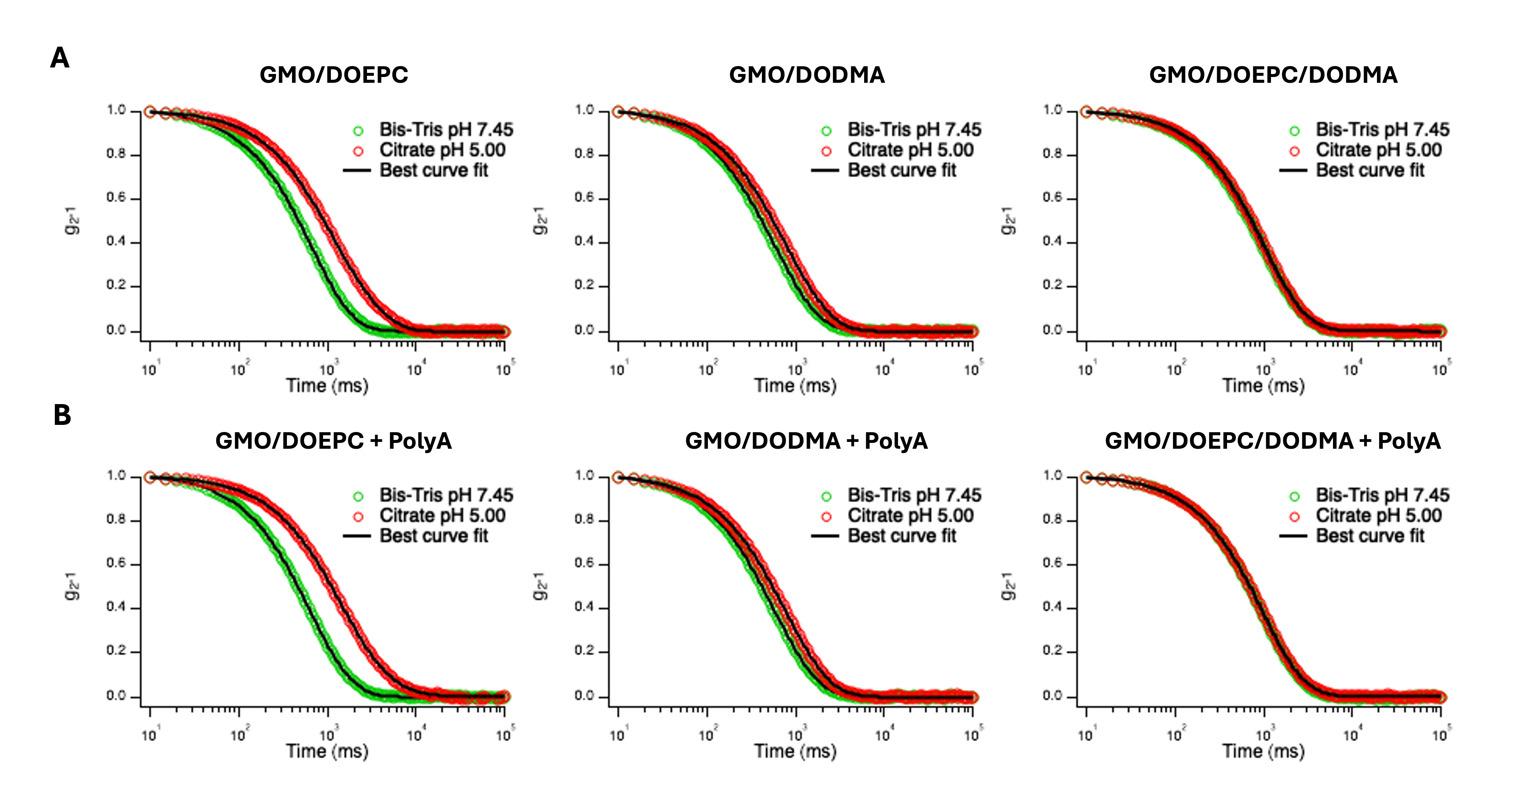Figure S1. Representative DLS intensity autocorrelation functions, together with best curve fits according to CONTIN, for GMO/DOEPC, GMO/DODMA and GMO/DOEPC/DODMA LNPs in the absence (A) and in the presence (B) of PolyA, in both 10 mM Bis-Tris (pH 7.45 ± 0.01) and 10 mM citrate (pH 5.00 ± 0.01). Curves were acquired in triplicate, at 25°C.

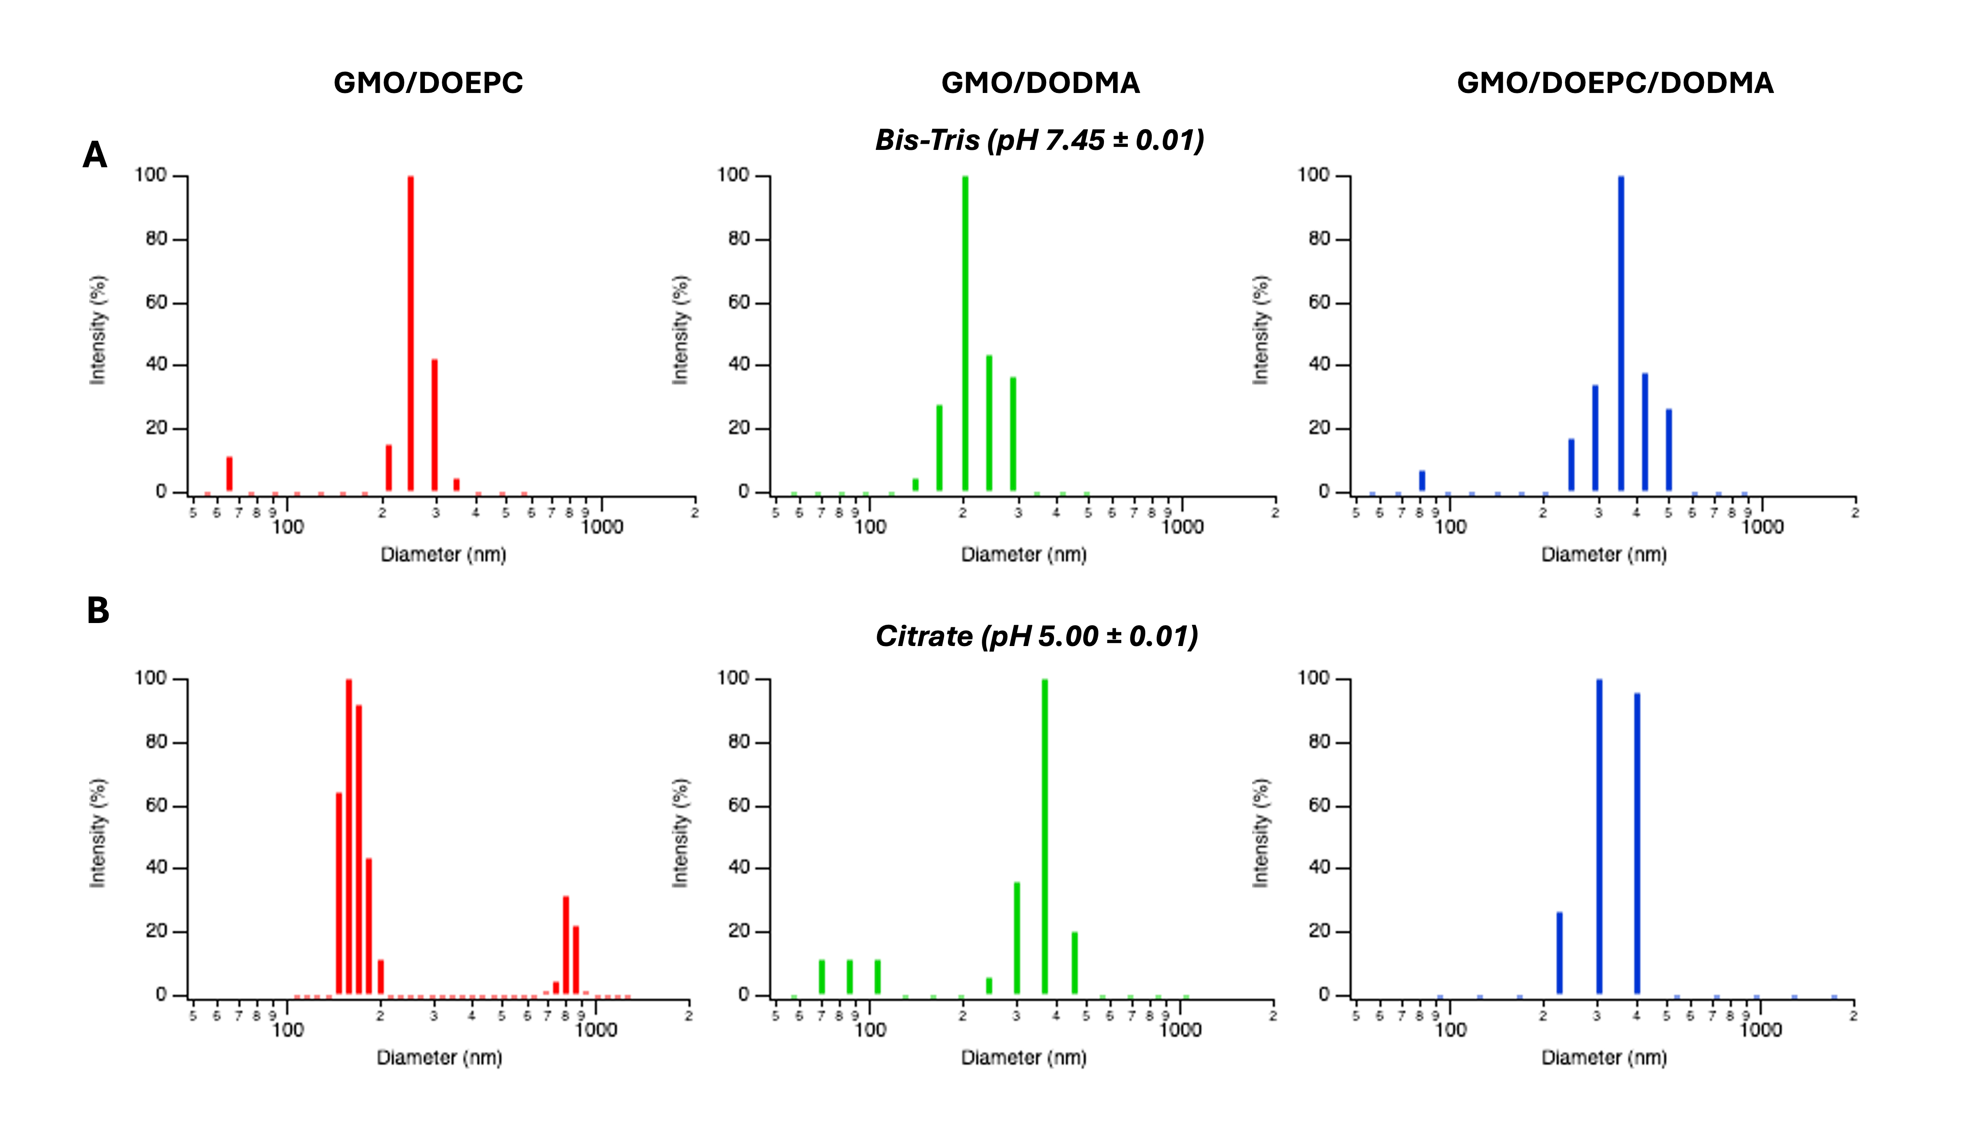Figure S2. Size distribution functions obtained from CONTIN analysis for GMO/DOEPC, GMO/DODMA and GMO/DOEPC/DODMA LNPs in the absence of PolyA, in 10 mM Bis-Tris (pH 7.45 ± 0.01) (A) and 10 mM citrate (pH 5.00 ± 0.01) (B).

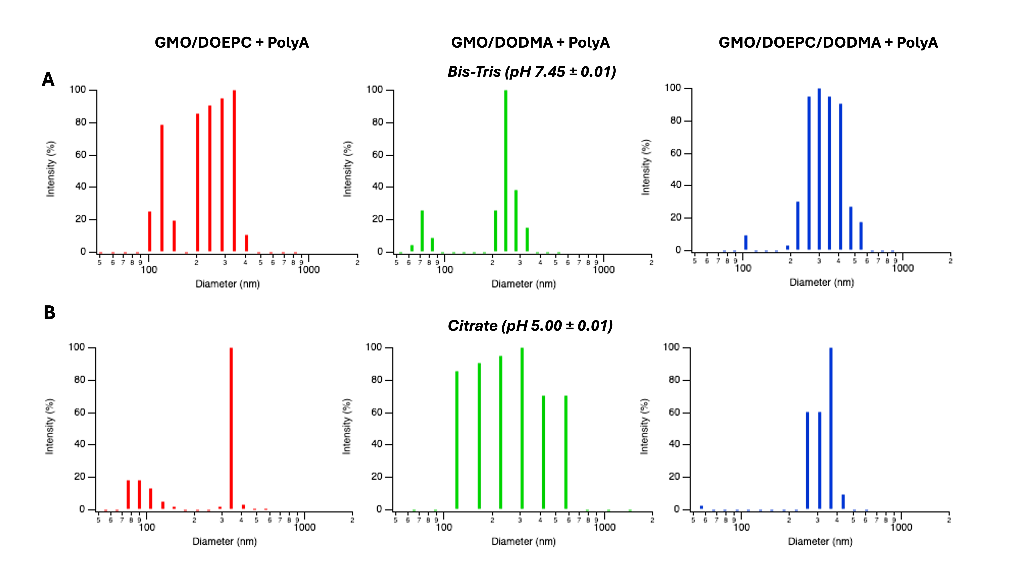Figure S3. Size distribution functions obtained from CONTIN analysis for GMO/DOEPC, GMO/DODMA and GMO/DOEPC/DODMA LNPs in the presence of PolyA, in 10 mM Bis-Tris (pH 7.45 ± 0.01) (A) and 10 mM citrate (pH 5.00 ± 0.01) (B).

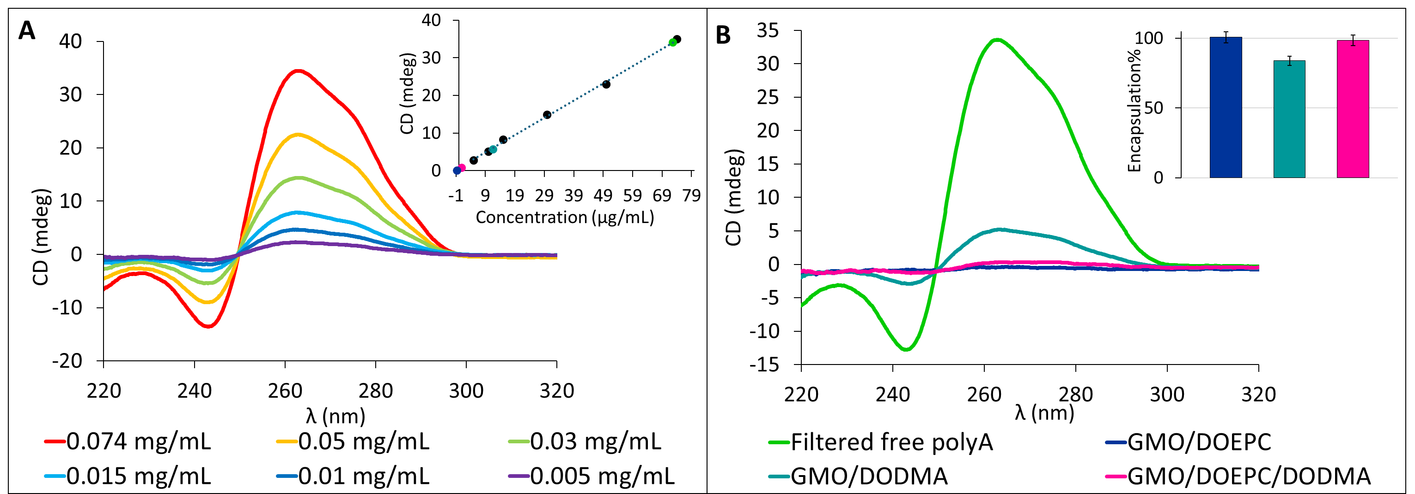
Figure S4. (A) Circular Dichroism (CD) spectra of PolyA at increasing concentrations in the range 5–74 μg/mL, recorded in citrate buffer and used to construct the calibration curve shown in the inset. (B) CD spectra of unencapsulated PolyA in citrate buffer, isolated upon filtration of PolyA-loaded LNPs. The inset reports the corresponding encapsulation efficiencies in percentage. Measurements were performed in triplicate.

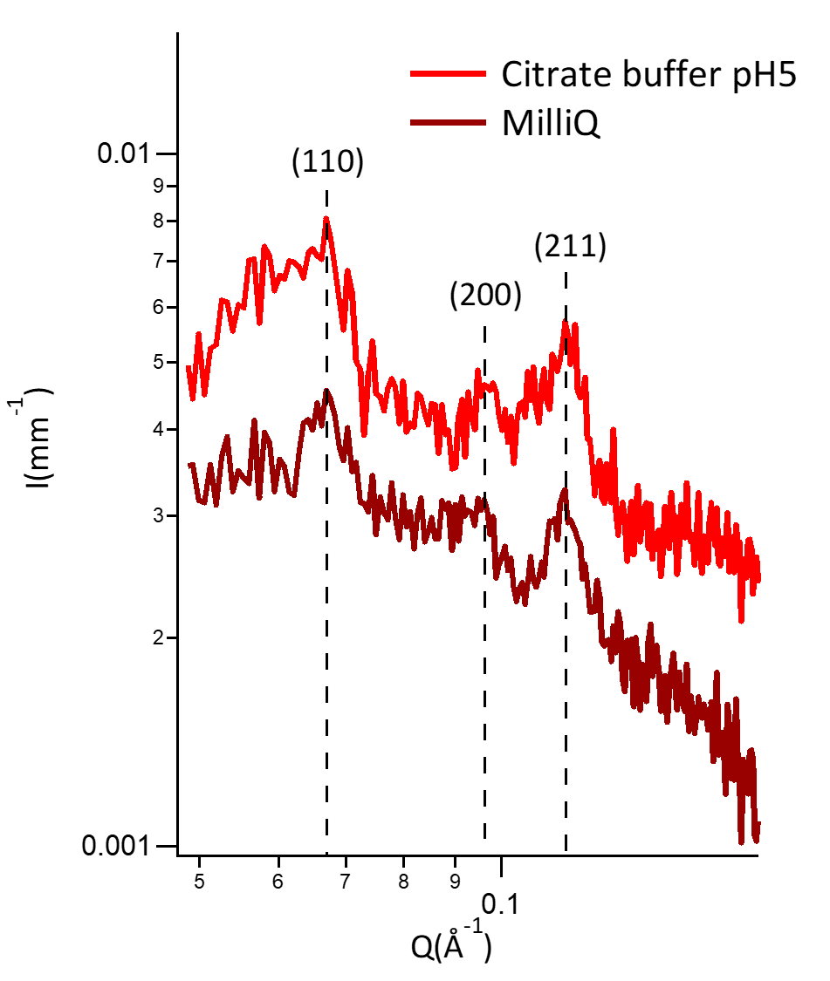
I (a.u.)
Figure S5. SAXS profiles of GMO/DOPE-PEG LNPs (devoid of cationic and ionizable lipids), either in 15 mM citrate buffer at pH 5.00 ± 0.01 (red profile) or in MilliQ water (brown profile), acquired at room temperature. Both profiles show the typical pattern of Bragg reflexes, whose Miller indices are indicated in the figure, corresponding to the Im3m cubic phase.

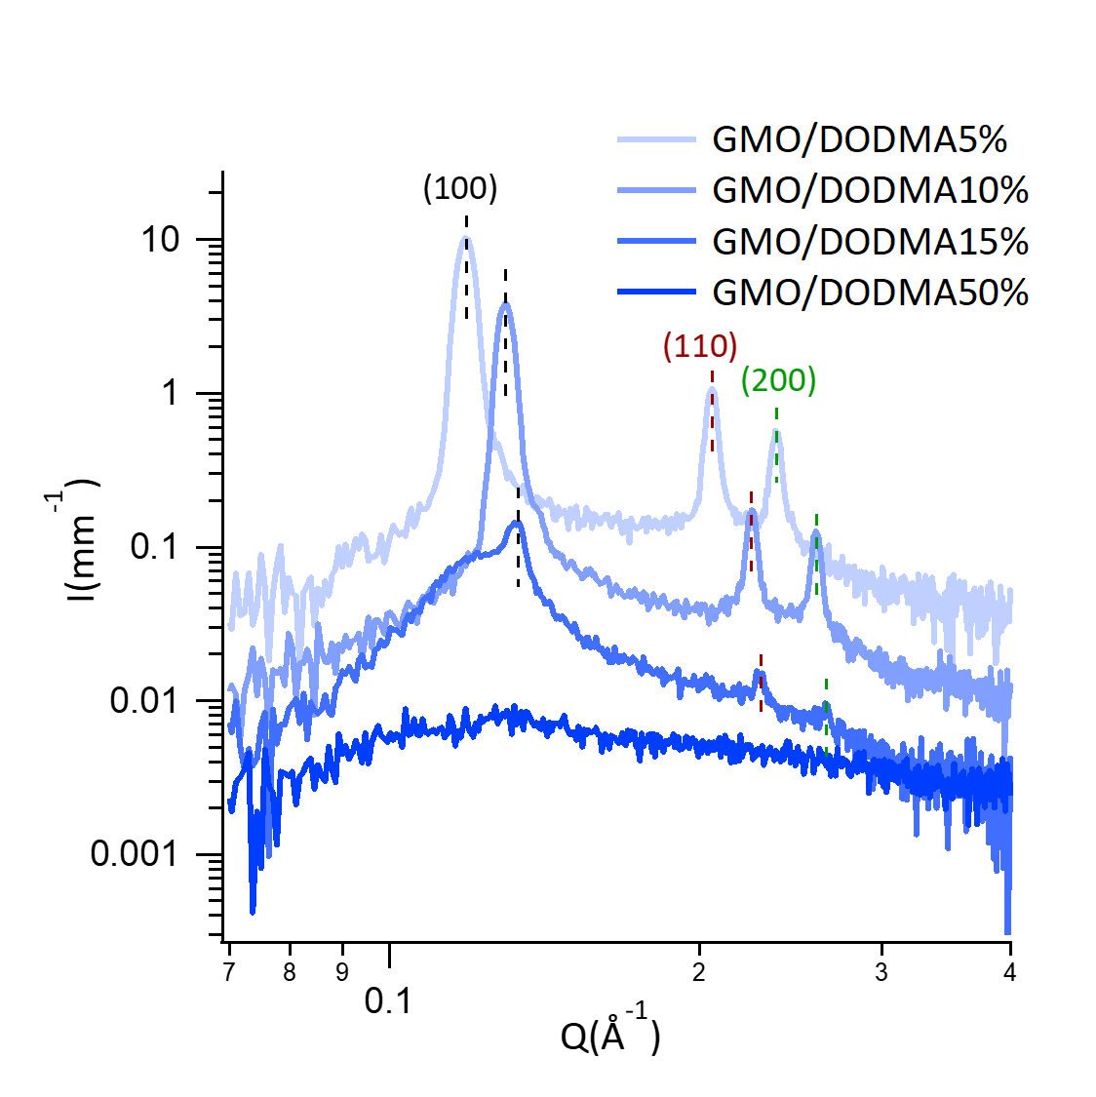
I (a.u.)
Figure S6. SAXS profiles of GMO/DODMA bulk assemblies in MilliQ water, prepared employing different DODMA amounts (from 5 to 50 mol%) and acquired at room temperature. For 5 and 10 mol% DODMA, the systems display an inverse hexagonal arrangement, as evidenced by the characteristic Bragg peak pattern, indexed with the corresponding Miller indices in the figure. At higher DODMA concentrations, this hexagonal order progressively disappears, as reflected by the loss of the associated Bragg peak pattern.

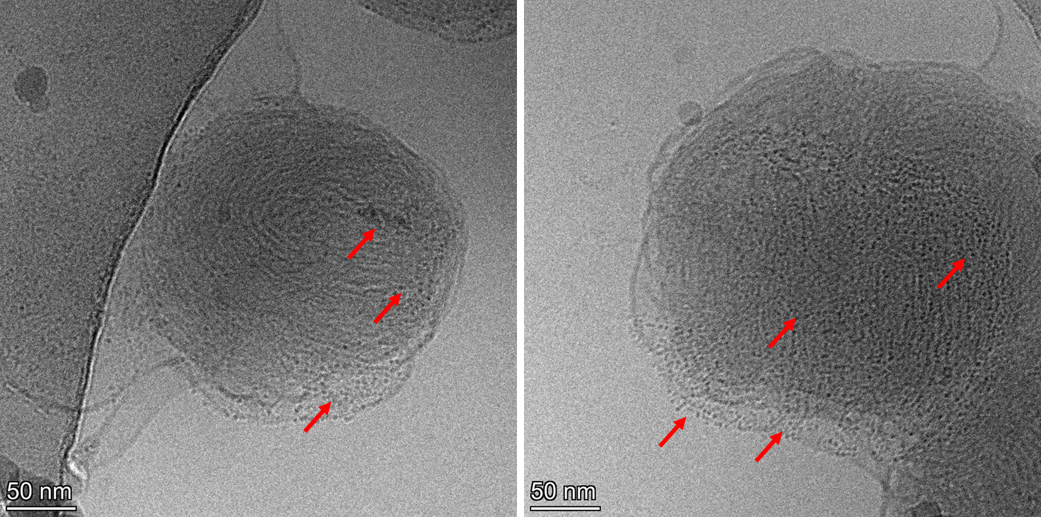
Figure S7. Additional Cryo-EM images of GMO/DOEPC/DODMA LNPs in 15 mM citrate buffer, pH 5.00 ± 0.01. Images display the presence of denser subdomains with mottled contrast (highlighted with red arrows), predominantly localized in LNPs featuring a hexagonal (left figure) or sponge (right image) arrangement.

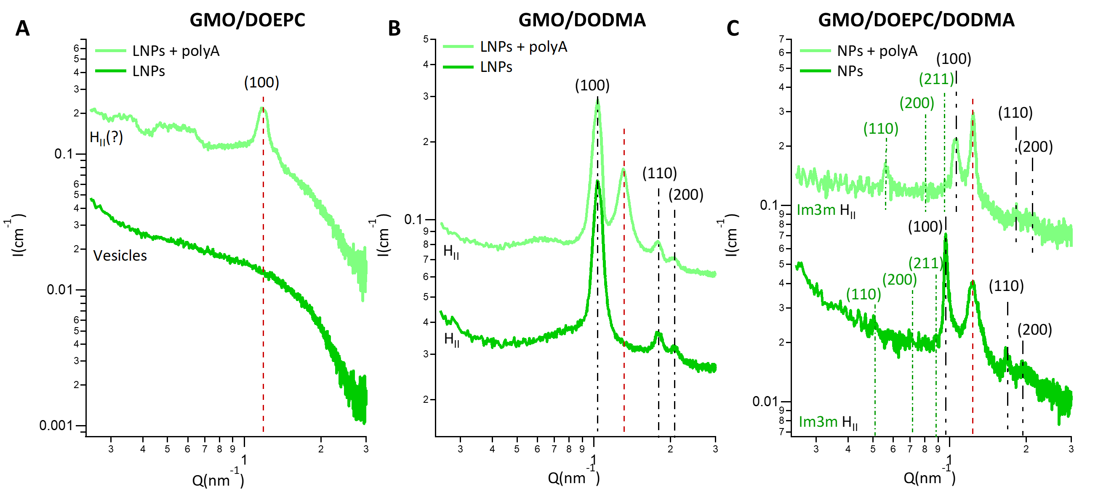
I (a.u.)
I (a.u.)
I (a.u.)
Figure S8. SAXS profiles of (A) GMO/DOEPC, (B) GMO/DODMA, and (C) GMO/DOEPC/DODMA LNPs, in the presence and absence of PolyA. SAXS profiles are acquired at 37°C in Bis-Tris buffer 15mM at pH 7.45 ± 0.01. The Bragg peak patterns characteristic of specific liquid-crystalline arrangements are indexed with the corresponding Miller indices in the figures, while the assigned phase is indicated below each curve. In the absence of PolyA, GMO/DOEPC LNPs exhibit an unstructured morphology (likely vesicular), as indicated by the lack of Bragg peaks. Upon PolyA addition, these particles undergo a transition to a liquid-crystalline arrangement, possibly an inverse hexagonal phase. GMO/DODMA LNPs display a hexagonal structure, which shifts to a secondary hexagonal arrangement upon PolyA loading. Similar to the phase behavior observed at pH 5, GMO/DOEPC/DODMA LNPs show the highest degree of structural heterogeneity, with coexistence of Im3m and HII phases, both with and without PolyA. Measurements were performed at least in triplicate.

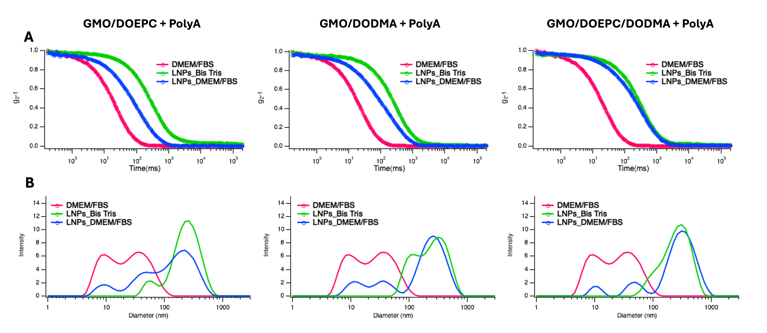Figure S9. Representative DLS intensity autocorrelation functions (A) and corresponding size distribution functions obtained from CONTIN analysis (B) for PolyA-loaded GMO/DOEPC, GMO/DODMA and GMO/DOEPC/DODMA LNPs, both in 10 mM Bis-Tris (pH 7.45 ± 0.01) and FBS-supplemented DMEM at the same pH. Data for FBS-supplemented DMEM alone (in the absence of LNPs) are also reported as control. All curves were acquired in triplicate, at 25°C.

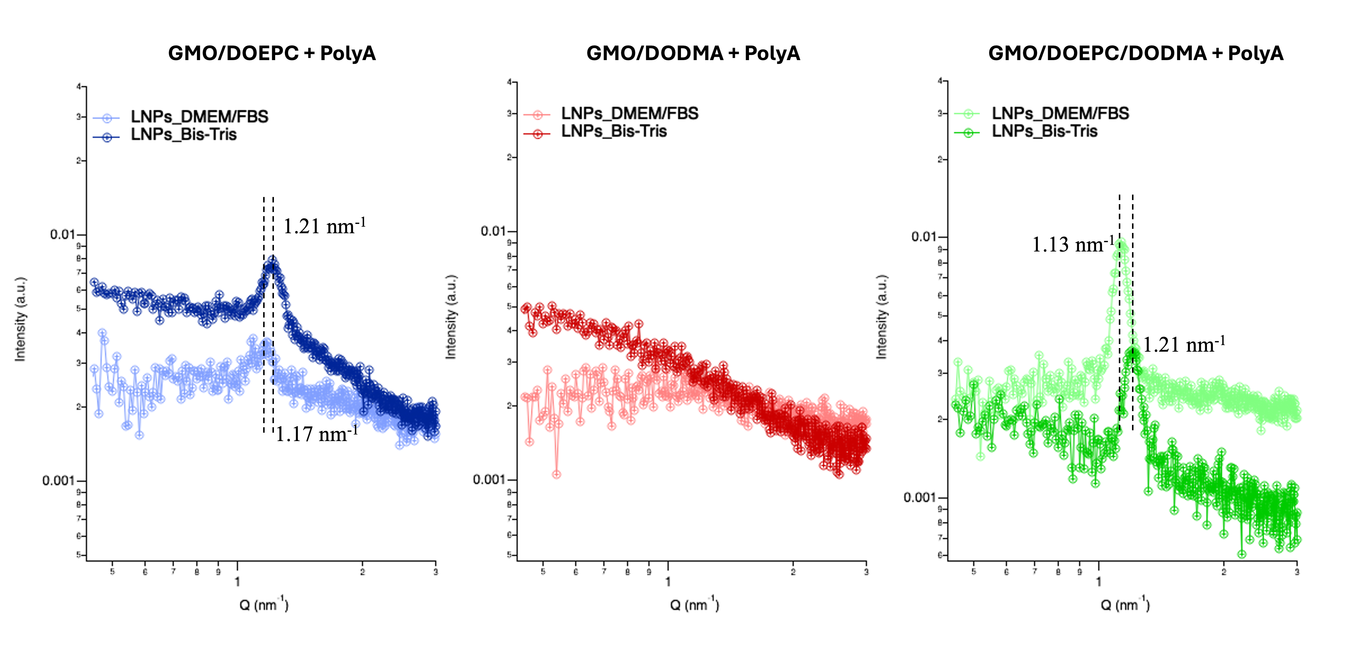Figure S10. SAXS profiles of PolyA-loaded GMO/DOEPC, GMO/DODMA, and GMO/DOEPC/DODMA LNPs measured in 10 mM Bis-Tris buffer (pH 7.45 ± 0.01) and in DMEM supplemented with 10% FBS. SAXS data were acquired at 37 °C using an in-house SAXS instrument (Xeuss 3.0, Xenocs), in contrast to all SAXS data reported in the main text of the manuscript, which were obtained at a synchrotron source. The q-position of the Bragg reflection is indicated by dashed lines in the figure and, for LNPs in Bis-Tris, coincides with the highest-intensity Bragg peaks observed in the synchrotron SAXS data shown in Figure S8.

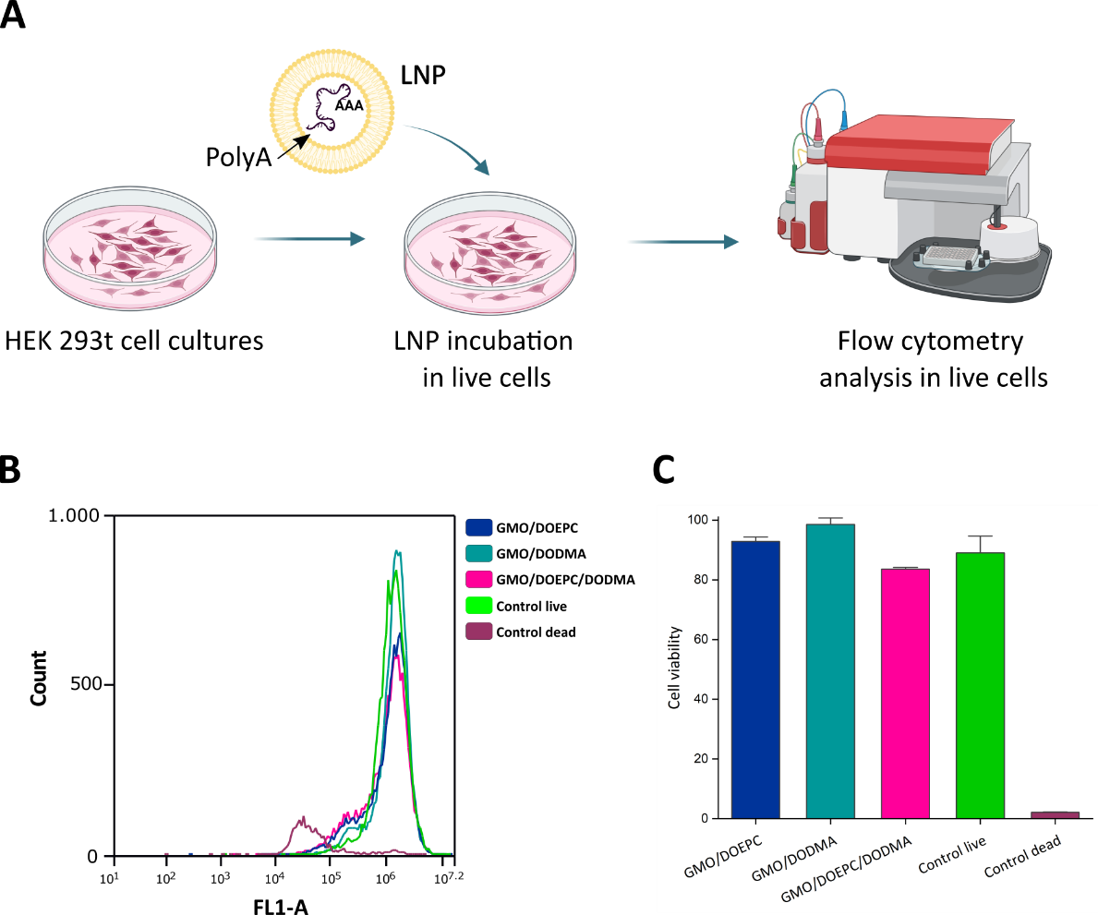
Figure S11. Cell viability assay by flow cytometry. (A) Live cells experiment workflow. Created with Biorender.com. (B) Histogram showing fluorescence intensity (FL1-A) versus cell count. Cells were incubated for 24h with 0.1 mg/mL GMO/DOEPC, GMO/DODMA and GMO/DOEPC/DODMA (all the formulations contain 1%mol of DOPE-PEG2000 as stabilizer) loaded with polyA. Subsequently, cells were incubated with calcein-AM to assess cell viability and then analyzed. (C) Cell viability results after 24h of incubation for each formulation. Triplicates of each sample were analyzed across 3 independent experiments. Error bars: SE

S3. Supplementary Tables

Table S1. Lattice parameters (d) and radius of water channel (Rw) for LNPs with and without polyA in buffer citrate 15 mM at pH 5.00 ± 0.01, derived from SAXS measurements reported in Figures 3, 4 and 5. The lattice parameters and the water channel radii were calculated as described in Section 1.1 of Supporting Information. Measurements were performed at least in triplicate. The uncertainty associated with all d and R_{w} values is ± 0.1 nm.

Sample | Phase | d (nm) | R_{w} (nm)
GMO/DOPE-PEG2000 | Im3m | 13.3 | 2.3
GMO/DOEPC | Pn3m | 13.7 | 3.6
GMO/DOEPC + polyA | Pn3m | 13.4 | 3.4
GMO/DODMA | Im3m | 16.2 | 3.2
GMO/DODMA | H_{II} | 5.2 | 1
GMO/DODMA + polyA | Im3m | 16.2 | 3.2
GMO/DODMA + polyA | H_{II} | 5.2 | 1
GMO/DOEPC/DODMA | Im3m | 16.8 | 3.4
GMO/DOEPC/DODMA | Pn3m | 14.6 | 3.9
GMO/DOEPC/DODMA | Im3m | 13 | 2.2
GMO/DOEPC/DODMA | H_{II} | 5.4 | 1.1
GMO/DOEPC/DODMA + polyA | Pn3m | 14 | 3.7
GMO/DOEPC/DODMA + polyA | Im3m | 12.8 | 2.1
GMO/DOEPC/DODMA + polyA | H_{II} | 5.4 | 1.1

Table S2. Lattice parameters and radius of water channel for LNPs with and without polyA in buffer Bis-Tris 15 mM at pH 7.45 ± 0.01, derived from SAXS measurements reported in Figure S2. The lattice parameters and the water channel radii were calculated as described in Section 1.1 Supporting Information. Measurements were performed at least in triplicate. The uncertainty associated with all d and R_{w} values is ± 0.1 nm.

Sample | Phase | d (nm) | R_{w} (nm)
GMO/DOEPC | - | - | -
GMO/DOEPC + polyA | H_{II} (?) | 5.3 | 2
GMO/DODMA | H_{II} | 6.1 | 2.8
GMO/DODMA + polyA | H_{II} | 6.1 | 2.8
GMO/DOEPC/DODMA | Im3m | 17.7 | 7.2
GMO/DOEPC/DODMA | H_{II} | 6.5 | 3.3
GMO/DOEPC/DODMA + polyA | Im3m | 15.9 | 6.1
GMO/DOEPC/DODMA + polyA | H_{II} | 5.9 | 2.6

Table S3. Hydrodynamic diameter (Dh), and ζ-Potential (ζ-pot) of PolyA-loaded GMO/DOEPC, GMO/DODMA, and GMO/DOEPC/DODMA LNPs in Bis-Tris buffer, 15 mM, pH 7.45 ± 0.01 and DMEM containing 10% FBS. Dh values were obtained from fitting of DLS autocorrelation curves according to the CONTIN analysis. Measurements were performed in triplicate.

 | Formulation | Dh (nm) | ζ-pot (mV)
 | GMO/DOEPC + PolyA in Bis-Tris | 235 ± 11 | +21 ± 1
 | GMO/DOEPC + PolyA in DMEM/FBS | 200 ± 28 | -25 ± 1
 | GMO/DODMA + PolyA in Bis-Tris | 240 ± 14 | -35 ± 1
 | GMO/DODMA + PolyA in DMEM/FBS | 258 ± 24 | -26 ± 1
 | GMO/DOEPC/DODMA + PolyA in Bis-Tris | 300 ± 22 | -6 ± 1
 | GMO/DOEPC/DODMA + PolyA in DMEM/FBS | 340 ± 28 | -24 ± 1

References

- Tyler, Arwen II, et al. Electrostatic swelling of bicontinuous cubic lipid phases. Soft matter 11.16 (2015): 3279-3286.
- Salvatore, Annalisa, et al. Multifunctional magnetoliposomes for sequential controlled release. ACS nano 10.8 (2016): 7749-7760.

