ENHANCING IN VIVO STABILITY OF [⁵²Mn]Mn(II) MACROCYCLIC COMPLEXES FOR PET application
Carlos Platas-Iglesiasª , Madalina Ranga^{b}, Charlene Harriswanglerª, James M. Omweri^{c} , Shefali Saini^{c}, Laura Valencia^{d}, David Esteban-Gómezª, Nicol Guidolin^{b}, Zsolt Baranyai^{b}, Suzanne E. Lapi^{c}.
ªUniversidade da Coruña, Galicia, Spain;^{b}Bracco Imaging SpA, CRB Trieste, Italy;^{c}University of Alabama, Birmingham, USA; ^{d}Universidade de Vigo, As Lagoas, Spain.
Positron Emission Tomography (PET) is a highly sensitive nuclear imaging technique that enables quantitative, whole-body visualization of biological processes using positron emitting radiotracers [1]. Among emerging PET radiometals, manganese-52 (⁵²Mn) is particularly attractive due to its long half-life (t_{1/2} = 5.6 days) allowing extended imaging studies.
A comparative study on the physico-chemical properties of the [^{nat}Mn/⁵²Mn]Mn(II) complexes with two 18-membered macrocyclic chelators, PYAN and CHXPYAN, is summarized in this work. Macrocycles of these ligands differ by the presence of ethyl or cyclohexyl bridges, with the latter offering increased rigidity to CHXPYAN. X-ray structures reveal that the Mn(II) ions in [Mn(PYAN)]²⁺ and [Mn(CHXPYAN)]²⁺ are six-coordinated by the nitrogen atoms of the macrocycles with very distorted octahedral geometries. Cyclic voltammetry shows reversible Mn(II)/Mn(III) redox behavior, indicating the resistance of these complexes against oxidation. The stability and the conditional stability of [Mn(PYAN)]²⁺ and [Mn(CHXPYAN)]²⁺ are very similar (logK_{MnL}=11.93, 12.51, pMn=7.18, 7.41, pMn = −log[Mn²⁺]_{free}, [Mn²⁺] =[L] = 10 μM at pH = 7.4, 0.15 M NaCl, 25°C). Both Mn(II) complexes dissociate via proton assisted pathways. Surprisingly, the kinetic inertness of the [Mn(CHXPYAN)]²⁺ is about four orders of magnitude higher than that of [Mn(PYAN)]²⁺. PET/CT scans and biodistribution assays revealed that [⁵²Mn][Mn(PYAN)]²⁺ has a similar distribution pattern to that of [⁵²Mn]MnCl₂, with persistent radioactivity accumulation in the kidneys and liver due to the partial dissociation of the [⁵²Mn][Mn(PYAN)]²⁺. Conversely, [⁵²Mn][Mn(CHXPYAN)]²⁺ remained stable in vivo, clearing fast from the liver and kidneys. These results demonstrate that CHXPYAN is a highly promising chelator for the development of ⁵²Mn(II)-based radiopharmaceuticals for PET imaging [2].
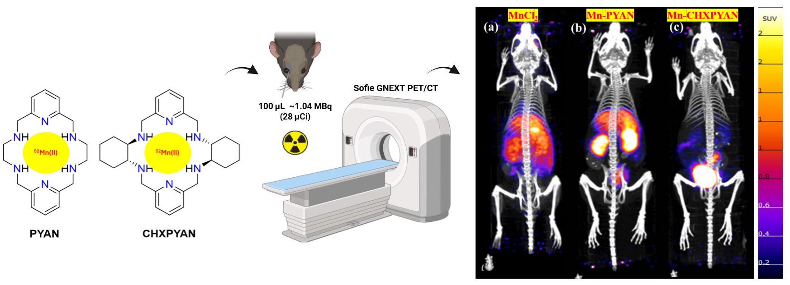
[1] I. F. Chaple, S. E. Lapi, J Nucl Med 2018, 59, 1655–1659.
[2] C. Harriswangler, J. M. Omweri, S. Saini, L. Valencia, D. Esteban-Gómez, M. Ranga, N. Guidolin, Z. Baranyai, S. E. Lapi, C. Platas-Iglesias, J. Med. Chem. 2024, 67, 11242–11253.

