Received 00th January 20xx,
- Department of Chemistry “Ugo Schiff”, University of Florence, Via della Lastruccia 3-13, 50019 Sesto Fiorentino (FI), Italy. Emails: matteo.savastano@unifi.it ; carla.bazzicalupi@unifi.it
Electronic Supplementary Information (ESI) available: Experimental details on the preparation and characterization of the crystals, crystallographic information, labelling schemes and associated collections of short contacts within the crystal structures, FT-Raman spectrum of DMSO concentrated solution of the I₅@BB(I₃)₃ crystals and associated spectroscopic data (PDF).
CIF files for I₅@BB(I₃)₃ and I₅@BB@(I₅)(I₃)₂ crystals (CCDC deposition numbers: 1957895 and 1957896, respectively) (CIF).See DOI: 10.1039/x0xx00000x
Accepted 00th January 20xx
DOI: 10.1039/x0xx00000x

Infinite Supramolecular Pseudo-Polyrotaxane with Poly[3]Catenane Axle: Assembling Nanosized Rings from Mono- and Diatomic I⁻ and I₂ Tectons.
Matteo Savastano,*ª Carla Bazzicalupi,*ª Cristina Gelliniª and Antonio Bianchiª
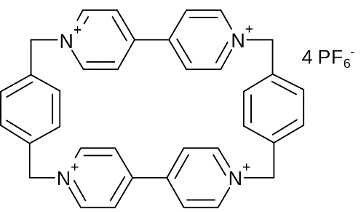
Mono- and diatomic I⁻ and I₂ building blocks, despite their simplicity, can be used to generate complex hierarchical self-assembled architectures. Construction of a modular supramolecular poly[3]catenane and its conversion into the axle of an infinite supramolecular pseudo-polyrotaxane have been achieved in a seamless process from the starting materials. Unique structural features, directionality, and iodine density of the obtained crystals envisage the benefits of a supramolecular design for polyiodide networks intended as solid-state conductors.
Mechanically interlocked compounds have been fascinating chemists over the last 20 years. The topic of molecular machines, once science fiction material, far exceeded its original boundary of a niche, futuristic and far from application research area to the point of finding ultimate (and yet most likely inaugural) consecration in the 2016 Nobel prize to Sauvage, Stoddart and Feringa.¹ That achievement is but the crowning of a long scientific tradition, that of Supramolecular Chemistry, proceeding from its founding fathers, Lehn, Pedersen and Cram, 1987 Nobel prize trio,^{2,3} and descending from a line of august ancestors which can be traced back to Paul Ehrlich’s receptor concept (1906),^{3,4} Emil Fischer’s lock and key model (1894)^{3,5} and further back still, perhaps arriving at the feeble force with which iodides can retain molecular iodine, a prelude to today’s halogen bonding, that can be found as early as 1814 in Gay Lussac’s writing on the properties of the just discovered iodine element.^{6,7}
Today we pay homage to this long tradition by pairing some of this most antique part, the supramolecular chemistry of

Figure 1. The BB tetracation
polyiodides, with one of the signature molecules of contemporary supramolecular chemistry: Stoddart’s Blue Box (BB) (cyclobis-paraquat-p-phenylene, Figure 1).⁸ BB is well known for its usefulness in preparing mechanically interlocked compounds and especially rotaxanes, being in fact one of the fundamental components of the first synthetic molecular shuttle.⁹ Interestingly, one of the routes to BB-based mechanically interlocked systems passes through iodide: heating BB in the presence of I⁻ triggers a reversible ring opening/closure mechanism which can and has been successfully used to generate catenanes through a threading approach.¹⁰ In all cases, production of catenanes has one obvious requirement: that of having, in the end, two macrocyclic components that can lock themselves one onto the other like rings of a chain.
Herein we report a quite a different BB-iodine chemistry, not that of the vigorous procedures of organic synthesis, but that of mild energy instead. The question that we asked ourselves is if it is possible to obtain a chain using a single type of macrocycle and some simple components, such as I⁻ and I₂, in a one-pot self-assembly fashion. Indeed, the I⁻/I₂ system is known to be able to generate great structural variety, owing to the hypervalency of iodine and the polarizability of polyiodides, which allows them to concatenate in a donor-acceptor fashion heavily dependent on local chemical environment and counterions.¹¹ Chains and ribbons of polyiodides, despite being reported,¹¹ have not been investigated for the preparation of interlocked compounds (to the best of our knowledge the first and only example is found in ref. 12). It is true that this kind of systems
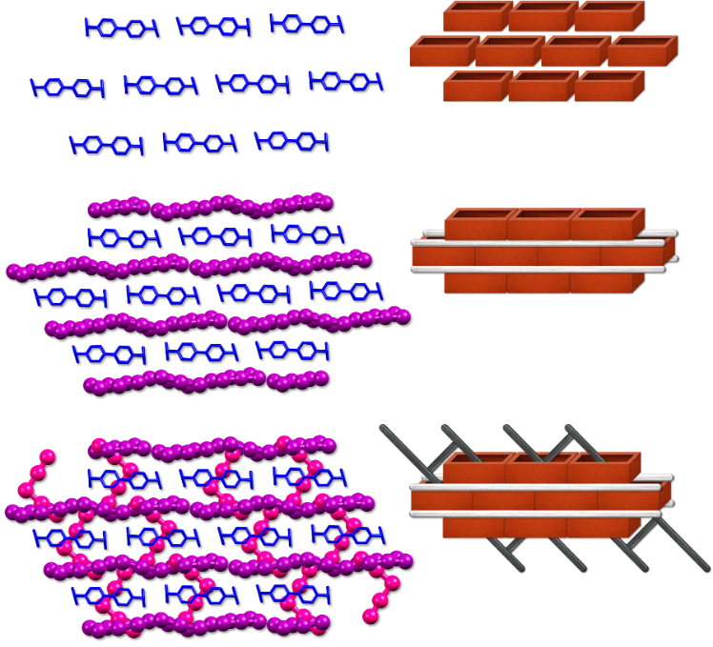
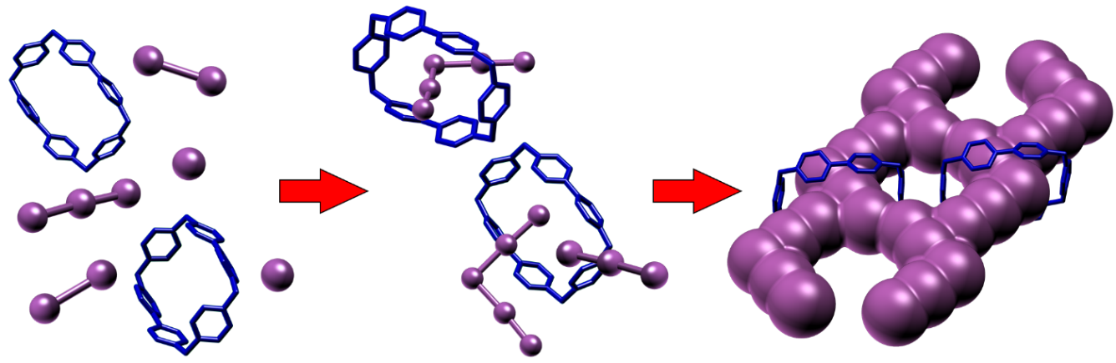
Figure 2. Schematic depiction of the evolution of the BB/I₂/I⁻ ternary system in acetonitrile solution. Preferential interaction of polyiodides (I₃⁻ and I₅⁻) with BB leading to their formation and encapsulation. I₅⁻@BB complexes organize themselves at a superior level to form an infinite supramolecular [3]catenate structure. BB is in blue according to Stoddart’s colour code convention.

Figure 3. Breakdown of the I₅@BB(I₃)₃ crystal structure. BB molecules are arranged in courses like bricks in a wall (top) held together by lines of triiodide anions, acting as the cement, running parallel to them (middle). The hollow brick wall features a reinforcement constituted by the chains of pentaiodides (bottom) forming the infinite catenane structure. Analogy with a brick wall structure shown on the right to help visualizing the mutual arrangement of the molecular components.
remain supramolecular in nature, i.e. the mechanical bond holding the pieces together does not possess the strength of covalency, yet the self-assembling of mono and diatomic components in strings, their tying onto organic macrocycles to give an infinite catenate and the consequential transformation of the catenate into the axle of a poly-pseudorotaxane of nanometric size, is unprecedented. We find this chemistry to be particularly intriguing on a synthetical, structural and material chemistry perspective, as we try to elucidate below.
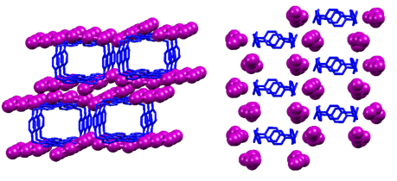
It suffices to let a BB(PF₆)₄ solution encounter by slow diffusion (within an H-shaped tube) a mol:mol 1:2 NaI/I₂ mixture in acetonitrile solvent to have spontaneous assembly of I⁻ and I₂ molecules in linear I₃⁻ anions, further reaction of I₃⁻ with I₂ to give bent I₅⁻ anions, selective hosting of the pentaiodide inside the BB cavity, self-assembly of I₅⁻@BB complexes to give fused 14-terms supramolecular polyiodide rings encompassing two interacting BB molecules each, and an infinite supramolecular [3]catenate is produced. To help the reader visualize it, the whole process is schematized in Figure 2.
Figure 4. I₅@BB(I₃)₃ crystal structure. (a) Columns of macrocycles and triiodides viewed along the a crystallographic direction. Only predominant individual shown, H atoms and pentaiodide anions omitted for clarity); (b) predominant individual viewed along the triiodides lines growth direction (pentaiodides omitted for clarity).
Analysis of the obtained crystals (Table S1), reveals that the obtained product has structurally more to do with brickwork. The rigid ligand molecules are arranged like bricks in a stretcher-type wall (Figure 3 top), while parallel lines of triiodide anions act as the cement sticking the brick courses (Figure 3 middle) through CH…I contacts (Table S2). Triiodide lines are disordered, being constituted by 2 individuals associated with 60% and 40% of the overall electron density. The two individuals are moved relative to each other by about 4.5 Å along the line’s growth direction (Figure S1). Both intramolecular distances and angles of the polyiodide species fall within typical ranges, indicating the permanence of a properly molecular character rather than a complete delocalization along the chain (Table S3).
Despite this, intermolecular contacts are manifestly short (in 3.7-3.9 Å range, cf. Table S4, i.e. meaningfully shorter than the sum of I…I vdW radii, ≈ 4.0 Å), indicating orbital contribution of the interacting partners to the interactions, in what is typically classified as iodine-iodine secondary bonds.
Focusing on the triiodides, each of the two individuals features three triiodide anions interacting head-to-tail with I-I-I∙∙∙I-I-I distances ranging from 3.58(1) to 3.90(1) Å (Table S4).
Prosecuting our similitude, the BB wall is entirely made of hollow bricks, whose holes align in parallel pillars, as we tried to portray in Figure 4. We can finally come to the pentaiodide anions, which develop an infinite supramolecular [3]catenane exploiting the void BB cavities, behaving in a certain sense as the reinforcement within a wall (Figure 3 bottom). Hosting of I₅⁻ within the BB cavity, beyond charge/charge reasons, is favoured
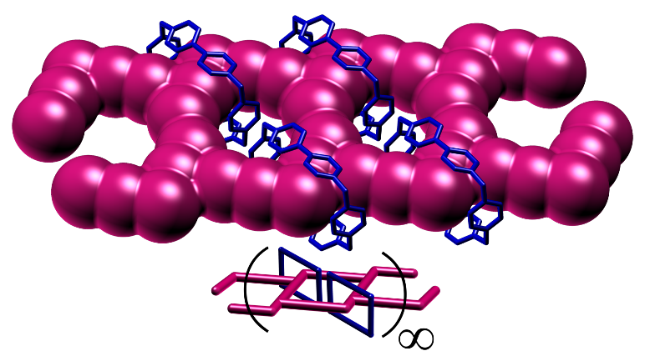
Figure 5. Nettings of 14-membered rings formed by the pentaiodide anions in the I₅@BB(I₃)₃ crystal structure. Inset: schematic depiction of the infinite supramolecular [3]catenane structure.
by its large surface, allowing the establishment of strong anion-π and van der Waals interactions with the hosting BB (see discussion below)
As displayed in Figure 5, pentaiodide anions hosted within pairs of adjacent and mutually interacting (through π-π stacking) BB molecules are connected through a network of significantly short I…I secondary bonds (3.5-3.6 Å, cf. Figure S2 and Table S4) giving rise to polymeric polyiodide chains based on fused 14-terms supramolecular rings.
The pentaiodide anion remains quite close to an ideal V geometry (angle 94.5°, inner I-I bonds 2.79 ± 0.01 Å, outer I-I bonds 3.12 ± 0.03 Å, cf. Table S3) despite some bending due to the formation of secondary bonds with neighbouring polyiodides (cf. Table S4).
This particular aspect was subject of further investigation with FT-Raman technique. Despite our efforts, it was not possible to directly record the spectra of the solid, as its strong absorption results in irreversible crystal damage. It was however possible to record the spectra of a solution of the complex obtained by dissolving the crystals in the minimum amount of DMSO. The obtained data are reported in Figure S3 and Table S5. Data show unambiguously the presence of the I₅⁻ anion, which appears to be symmetric V-shaped in accordance with crystallographic data.^{11,13-15} This appears as an indication of the survival of the discrete I₅@BB complex even in concentrated solution.
Perhaps the most striking aspect of structural intricacy of this architecture is the fact that it is possible to convert it to an infinite pseudo-polyrotaxane with the same modular [3]catenane axle by simply increasing the iodine content in the crystallization medium.
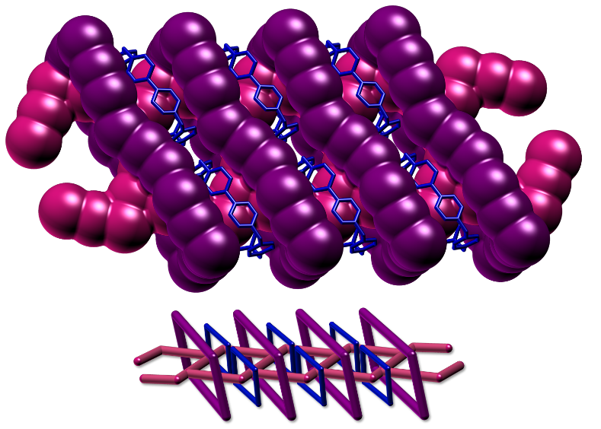
By doing so, crystals of I₅@BB@(I₅)(I₃)₂, i.e. formally containing an extra I₂ molecule per BB, are obtained. Despite being isomorphous with I₅@BB(I₃)₃ crystals, the conversion of one of the linear triiodides into a bent pentaiodide means the branching of the triiodide linear structure and the closure of extremely large, 22-terms, polyiodide rings, constituted by 2 pentaiodides and 4 triiodides each. Such closure happens through halogen bonding of the newly formed pentaiodide anions with the neighbouring line of triiodide cement (again present as two individuals, this time associated with 50% of electron density each; details in ESI Experimental section, Figures S4 and S5). This actively turns the infinite [3]catenane structure into the axle of an infinite supramolecular pseudo-polyrotaxane, as illustrated in Figure 6. Detailed information about I-I bond lengths and angles (Table S6), I…I (Table S7) and CH…I supramolecular contacts distances (Table S8) are given in the ESI.
Figure 6. Infinite supramolecular pseudo-polyrotaxane with a [3]catenane axle constituting the I₅@BB@(I₅)(I₃)₂ crystal. Inset: schematic depiction of the interlocked systems.
The fact that the core [3]catenane axle remains unvaried from one structure to another may be indicative of a remarkable stability of the I₅@BB catenate complex. Closer inspection reveals that the I₅@BB complex as found in the crystal structures, beyond the host and guest mutual size which allows for significant surface contact, is mainly stabilized by 4 concomitant anion-π interactions involving all the pyridinium centres (Table S9). We have previously investigated about the . significance of anion-π interactions for the construction of polyiodide networks:¹⁶ given the persistence of this type of interactions in solution even with non-cage electron-deficient aromatics,^{17,18} and the observation of I₅⁻ in solution through FT-Raman, an involvement of anion-π contacts in the genesis of these crystals from the mother solution could be postulated. As commented above, a second important contribution to the self-organisation into catenates comes from the π-π stacking between adjacent BB molecules, which are invariably found aligned in a face to face fashion.
Polyiodide chemistry, a worthy and long-lasting research field connected with structural and theoretical challenges posed by the hypervalent behaviour of iodine, has recently re-flourished due to its relevance for solar energy harvesting and storage, e.g. dye-sensitized solar cells and batteries, where polyiodide species are mostly included as electrolytes.^{19,20} Concomitantly, solid-state conductors based on the Grotthuss conduction mechanism^{11,21} also returned into the spotlight.²²⁻²⁴ It is important to understand that both micro- but also macroscopic requirements should be fulfilled to achieve highly performing polyiodide-base conductors. On a microscopic level, orbital contacts within a train of polyiodides spanning the whole crystal is required to maintain electrical contact through an electron hopping mechanism. Nevertheless, short I…I intermolecular contacts and a large number of wires per unit area, both affected by iodine density within the crystal, would surely enhance its conduction, as experimentally demonstrated.^{11,25,26}
We recently introduced the novel descriptor I_{N}, which allows to compare and assess, on a meaningful scale, the iodine packing density in crystals. The iodine number I_{N} was defined to assume a 0 value in the absence of iodine and a value of 1 for a crystal possessing the same iodine packing density of molecular I₂ crystals.²⁸ Comparison of different polyiodides, based on their crystal structures, is eased by the use of this descriptor. For instance, it allowed us to evidence that very high iodine density (up to I_{N}=0.589) can be achieved in iodine-based clathrates of small protonated azacyclophanes, deliberately mismatching in size with the iodide anions,²⁸ compared to the lower, although significant, iodine densities (up to I_{N}=0.330) we previously obtained with tetrazine-based ligands²⁷ forming polyiodide planes instead of wires.¹⁶
The I₅@BB(I₃)₃ and I₅@BB@(I₅)(I₃)₂ polyiodides herein reported are particularly promising from a material chemistry perspective, since they satisfy both the macro- and microscopic criteria required for electrical conductivity: i) they contain trains of polyiodides spanning the crystal from side to side while maintaining meaningful orbital overlap (microscopic); ii) they are characterized by significant iodine packing density (I_{N}=0.447 for I₅@BB(I₃)₃, I_{N}=0.487 for I₅@BB@(I₅)(I₃)₂) (macroscopic).
Furthermore, these new compounds highlight that the use of large and rigid organic scaffolds, inherently inclined to organize in pillars at the solid state, like BB, could be a striking strategy to promote the formation of polyiodide networks developing along well-defined directions, without sacrificing much of the final iodine packing density of the material.
In conclusion herein we reported an interesting case of spontaneous one-pot self-assembly of a unique pentaiodide-based infinite supramolecular [3]catenate starting from an aromatic tetracationic pyridinophane and I⁻/I₂ mixture. Closure of further polyiodide rings can be achieved by simply increasing the iodine content of the crystallization medium, leading to an unprecedented infinite supramolecular pseudo- polyrotaxane on a poly[3]catenate axle. Mono- (I⁻) and diatomic (I₂) tectons are observed to spontaneously assemble into complex architecture including discrete 22-terms rings ((I₅)₂(I₃)₄) and I₅@BB catenate networks featuring 14-terms rings, entirely assembled through the cooperation of anion-π and π-π stacking forces. Lastly, beyond scientific and applicative interests, we feel for once that the reported structures could be one of those inspiring fascinating little curios which remind us all of the beauty of chemistry.
Conflicts of interest
There are no conflicts to declare.
Notes and references
- Press release: The Nobel Prize in Chemistry 2016. NobelPrize.org. Nobel Media AB 2019. <https://www.nobelprize.org/prizes/chemistry/2016/press-release/> (Accessed September 20, 2019).
- Press release: The Nobel Prize in Chemistry 1987. NobelPrize.org. Nobel Media AB 2019. <https://www.nobelprize.org/prizes/chemistry/1987/press- release/> (Accessed September 20, 2019).
- J. W. Steed, J. L. Atwood, P. A. Gale (2012). Definition and Emergence of Supramolecular Chemistry in Supramolecular Chemistry (eds P. A. Gale and J. W. Steed).
- C.-R. Prüll, Med. Hist., 2003, 47(3), 332-356.
- E. Fischer, Ber. Dtsch. Chem. Ges., 1894, 27, 2985-2993.
- J.L. Gay-Lussac, Ann. Chimie, 1814, 91, 5–160.
- G. Jones, J. Phys. Chem., 1930, 34, 673–691.
- B. Odell, M. V. Reddington, A. M. Z. Slawin, N. Spencer, J. Fraser Stoddart, D. J. Williams, Angew. Chem. Int. Ed. Engl., 1988, 27, 1547-1550.
- P.L. Anelli, N. Spencer, J. Fraser Stoddart, J. Am. Chem. Soc., 1991, 113(13), 5131-5133.
- K. Patel, O. Š. Miljanic, J. Fraser Stoddart, Chem. Commun., 2008, 1853-1855.
- P.H. Svensson, L. Kloo, Chem. Rev., 2003, 103, 1649–1684
- Z. Wang, Y. Cheng, C. Liao, C. Yan, CrystEngComm, 2001, 3, 237-242.
- Y. Liang, T. Yamada, H. Zhou, N. Kimizuka, Chem. Sci., 2019, 10, 773-780.
- C. Pei, T. Ben, S. Xu, S. Qiu, J. Mater. Chem. A, 2014, 2, 7179-7187.
- P.H. Svensson, L. Kloo, J. Chem. Soc., Dalton Trans., 2000, 2449-2455.
- M. Savastano, C. Bazzicalupi, C. García-Gallarín, C. Gellini, M.D. López de la Torre, P. Mariani, F. Pichierri, A. Bianchi, M. Melguizo, Dalton Trans., 2017, 46, 4518–4529.
- P. Arranz-Mascarós, C. Bazzicalupi, A. Bianchi, C. Giorgi, M.L. Godino-Salido, M.D. Gutierrez-Valero, R. Lopez-Garzón, M. Savastano, J. Am. Chem. Soc., 2013, 135, 102–105.
- M. Savastano, C. Bazzicalupi, C. García-Gallarín, C. Giorgi, M.D. López de la Torre, F. Pichierri, A. Bianchi, M. Melguizo, Dalton Trans., 2018, 47, 3329–3338.
- J. Wu, Z. Lan, J. Lin, M. Huang, Y. Huang, L. Fan, G. Luo, Chem. Rev., 2015, 115, 2136–2173.
- F. Bella, S. Galliano, M. Falco, G. Viscardi, C. Barolo, M. Grätzel, C. Gerbaldi, Chem. Sci., 2016, 7, 4880–4890.
- C.J.D. De Grotthuss, Ann. Chim., 1806, 58, 54–73.
- J. Li, Z.-S. Wang, RSC Adv., 2015, 5, 56967–56973.
- H. Wang, J. Li, F. Gong, G. Zhou, Z.-S. Wang, J. Am. Chem. Soc., 2013, 135, 12627–12633.
- H. Wang, H. Li, B. Xue, Z. Wang, Q. Meng, L. Chen, J. Am. Chem. Soc., 2005, 127, 6394–6401.
- H. Stegemann, A. Rohde, A. Reiche, A. Schnittke, H. Füllbier, Electrochim. Acta, 1992, 37(3), 379-383.
- S. Kusabayashi, H. Mikawa, S. Kawai, M. Uchida, R. Kiriyama, Bull Chem. Soc. Jpn., 1964, 37, 811.
- M. Savastano, C. García-Gallarín, M.D. López de la Torre, C. Bazzicalupi, A. Bianchi, M. Melguizo, Coord. Chem. Rev., 2019, 397, 112-137.
- M. Savastano, A. Martínez-Camarena, C. Bazzicalupi, E. Delgado-Pinar, J.M. Llinares, P. Mariani, B. Verdejo, E. García-España, A. Bianchi, Inorganics, 2019, 7(4), 48.

